

Council Office, 122 Sea Road, East Preston, West Sussex. BN16 1NN

01903 770050 http://eastpreston.arun.gov.uk/ Email: epparishcouncil@btconnect.com

MINUTES: | of the Proceedings of the Monthly Meeting of East Preston Parish Council held on Monday, 7th January 2019 at the East Preston Infant School, Lashmar Road, East Preston at 19:00.
PRESENT: | Councillors Christine Bowman, Andrea Chapman, Lisa Duff, Barbara Gale, Pat Gander, Elizabeth Linton, Glyn Mathias, Rick McElroy, Steve Toney (Chairman) and Steve Wilkinson
ALSO: | Clerk to the Council, Simon Cross  District Councillor Terry Chapman (until 20:10)  Ms Georgina Bouette and Mr Matt Rookes, Arun District Council Community Safety Team (both until 19:53)  Four members of the public
ABSENT: | Councillors David Moore and Danny Shah

* * * * *

The following abbreviations may appear in these Minutes:

ADC – Arun District Council;  BTP – British Transport Police;  JEAAC – Joint Eastern Arun Area Committee;  NHS – National Health Service;  CPRE – Campaign for the Protection of Rural England | NR – Network Rail;  SSALC – Sussex and Surrey Associations of Local Councils;  VHF – East Preston & Kingston Village Hall Foundation;  WSCC – West Sussex County Council;

* * * * *

The meeting opened at 19:02.

001/19 INTRODUCTIONS

Cllr Toney welcomed those present, wished everyone a happy new year, led a round of introductions and explained some items of meeting protocol.

002/19 FORMER COUNCILLOR, DAVID QUICK

Cllr Toney read the following statement:

“Before this evening’s meeting continues, I ask you all to join me in one minute’s silence in memory of former councillor, David Quick, who sadly died on the evening of Saturday, 22nd December after a long period of variable health.

“David joined the council in May 2011 but ill health forced him to resign in January 2012.

“More recently, David was Chairman of the Disability Action Group of East Preston, leading the campaign to raise funds for the kitting out of the soon to be refurbished toilet block in Sea Road. To date, the group has raised over £6,000 towards the project.

“Our thoughts are with David’s family, particularly his wife Jan.

“Please join me now in a minute’s silence in memory of David; please feel free to stand or remain sitting as you prefer.”

This was followed by one minute’s silence in honour of Mr Quick.

003/19 FORMER DISTRICT COUNCILLOR, DENNIS WILDE

Cllr Toney invited District Cllr Chapman to address the meeting.

(Throughout this Minute, Cllr Chapman refers to District Cllr T Chapman not Parish Cllr A Chapman.)

Cllr Chapman remembered former District Councillor Wilde as an intensely private man. Mr Wilde could point to a long commitment to local government, both in his sixteen years of continuous service for East Preston & Kingston on Arun District Council, May 1999 to May 2015, and prior to that representing Ripley on Guildford Borough Council. In the 2011/2012 council year, Mr Wilde had been a popular and highly effective Chairman of Arun District Council, using his quiet sense of humour to the benefit of the council and the District as a whole. Away from the council, Mr Wilde had run a highly successful import and export business.

Cllr Chapman led those present in one minute’s silence in honour of Mr Wilde.

004/19 APOLOGIES FOR ABSENCE

An apology and a reason for absence had been received and were accepted from Cllr Moore and Cllr Shah (both away).

An apology had also been received from County Councillor Elkins and from District Councillor Bower.

005/19 DECLARATION OF INTERESTS

No declarations were made.

006/19 ARUN DISTRICT COUNCIL, COMMUNITY SAFETY

Cllr Toney welcome Ms Georgina Bouette and Mr Matt Rookes to the meeting.

Ms Bouette explained they had been invited to the meeting to talk about anti-social behaviour in the village. Ms Bouette is a Community Manager for ADC and Mr Rookes is an anti-social behaviour caseworker. Mr Rookes is one of two caseworkers in the team, both working closely with Sussex Police out of either Littlehampton or Bognor Regis police stations. The team is responsible for Community Safety in the District and is a vital part of the Safer Arun Partnership which includes other agencies such as WSCC and Sussex Police, in particular Inspector Steve Turner.

There are two recent reports posted to the ADC website that outline performance of the local Community Safety Partnership, These provide a useful overview of what the team has tackled and achieved over the year working with local partners. These can be accessed by searching the ADC website for:

Arun District Council Environment & Leisure Working Group of 9 October 2018: Safer Arun Partnership Annual Review of 2017 – 18

Arun District Coucnil Housing & Customer Services Working Group – 13 December 2018: Community Safety & Housing Partnership Working Review 2016 – 2018

Ms Bouette said the team liked working closely with town and parish councils as these often had good links with the communities they represented. She was looking at reconvening the Joint Action Group.

The team had a number of different intervention methods at their disposal, depending upon the impact of the anti-social behaviour and whether previous methods have not been successful. Interventions often started with a simple home visit, and where young people are involved this includes their parents in the discussion. The aim was to offer young people every opportunity to change their behaviour, to steer them away from a criminal path. Where there was a large community impact, more stringent measures and injunctions could be put in place.

The team works closely with Arun Community Church (ACC) on outreach projects.

A lot of the team’s work was also to try and prevent the exploitation of young people in the local area and to keep those young people safe working with children’s social care partners and the police.

Ms Bouette reported there had been an increase in reports of anti-social behaviour in East Preston and Angmering in the past year. However, there are still too few reports being made to Sussex Police and this made it difficult for the Community Safety team to provide the necessary evidence with which to involve Sussex Police. Where there was anecdotal evidence of anti-social behaviour, Mr Rookes would do a letter-drop to local households stressing the importance of reporting issues.

Mr Rookes understood people of all ages were sometimes afraid to report incidents for fear of reprisals. The team’s work is carried out in the strictest confidence and this is partly why it is sometimes impossible for reporters to be given any feedback on their reports. Additionally, there was often just not enough time for the time to feed back to the reporter. Ms Bouette said the Joint Action Team would look at providing better, generic feedback to communities to underline the work being done.

If an incident was in progress, witnesses should not hesitate to call 999 for Sussex Police to attend as soon as possible. For non-urgent reports, witnesses should call 101 or report online via the Sussex Police or CrimeStoppers websites. Cases of anti-social driving should be reported via the Operation Crackdown website.

Ms Bouette advised the team would not usually get involved in neighbour disputes. Where adults were behaving anti-socially, the team had access to a range of other agencies who were able to assess the vulnerability of the adult and whether other agencies needed to be involved. Cases where there might be mental health issues, for example, are passed on to Adult mental health services and / or adult social care at WSCC.

A visible police presence made residents feel safer. Sometimes it was as simple as leaving a marked police car somewhere highly visible that detracted people from anti-social behaviour.

District Cllr Chapman reported the East Preston Youth Club had started running a second night each week, on a Tuesday. This was aimed at the 15+ age group and had been initially successful, but there was a belief people of the appropriate age group were now being scared off attending and the second evening is currently cancelled. Cllr Mathias said the youth workers from ACC were now out and about in the community instead.

In response to a question, Ms Bouette said the team did not attempt to tackle the root causes of anti-social behaviour. The team’s immediate task was to stop anti-social behaviour and / or take action to prevent it from escalating. Through annual performance measures, the Arun ASB Team have had 97% success over the last two years in stopping anti-social behaviour by identified perpetrators (adults and young people) in the District. Furthermore, the increased presence of British Transport Police at Angmering Station is attributable to the Community Safety team’s intelligence about anti-social behaviour there and close working with the local police Prevention team.

One of the Safer Arun Partnership’s priorities is to educate the public and local councillors about the work the Community Safety and wider partnership does and how the public can help. The team used to do educational visits into schools but currently did not have the resources to do so. The team was still going into schools for individual cases and had strong links with local secondary schools in particular.

Mr Rookes ended by reminding the meeting schools also have a dedicated Sussex Police youth officer, in this area PC Claudine Bishop. Cllr Chapman confirmed she had seen PC Bishop meeting children at local schools.

(Ms Bouette, Mr Rookes and Mrs Amoo left the meeting at the conclusion of this item.)

007/19 PUBLIC SESSION

Agenda Item 10, Matters from previous Full Council meetings – Mrs Lee wished the council a very happy new year and said she was sorry to have missed the recent Christmas Celebrations event held on 24th November. Mrs Lee said she had heard very good reports of an enjoyable afternoon despite the weather not being the best.

Mrs Lee said the provision of a school bus to bring children from Angmering into East Preston was a priority. Parents parking in North Lane and other roads near to the schools were causing real problems for local residents.

Mrs Lee noted the council was setting its budget and precept this evening, but asked again whether something could be done about the bank at the south-western corner of Lashmar Road.

Mrs Lee also asked again about the fingerpost on the northern side of the Roundstone Level Crossing and whether the laughable replacement commissioned by Angmering Parish Council could be replaced at this council’s expense.

Finally, Mrs Lee finished by saying property on the corner of Pinewood Close and North Lane had prickly foliage overhanging the pavement.

Mrs Wallace added she was saddened by the passing of Mr Quick whom she believed had been working for the village right up until the end.

008/19 COUNCILLOR RESPONSES

The Clerk replied the Amenities Committee could discuss the Lashmar Road bank at its meeting on 21st January – Chairman of the committee, Cllr McElroy, agreed.

The matter of a school bus was really something for County Cllr Roger Elkins to respond to. The Clerk had previously advised the pupils coming from Angmering to East Preston schools did not fit the criteria for a school bus service as the children lived within two miles of their closest suitable school, regardless of whether they used that school or not. Cllr Elkins was possibly best-placed to explain any possible ways around the policy.

The Clerk said he would report the overhanging foliage to WSCC.

009/19 WEST SUSSEX COUNTY COUNCIL (WSCC)

County Cllr Elkins had sent his Apologies for the meeting.

010/19 ARUN DISTRICT COUNCIL (ADC)

(Throughout this Minute, Cllr Chapman refers to District Cllr T Chapman not Parish Cllr A Chapman.)

Cllr Chapman reported he was still confident a Registered Community Benefit Society would be set up in time for a lease to be agreed with ADC to start on 1st April. It was likely ADC would pay the expenses associated with putting the new lease in place.

Cllr Chapman noted the parish council was voting on its budget and precept for the coming financial year. Cllr Chapman said he wanted to stress, both as a resident and as a District Councillor, the parish council provided “very good value for money.” From the Village Orderly litter-picking over the Christmas break to the events the council ran, Cllr Chapman felt this council worked to a level of detail not seen elsewhere. He concluded by saying the council provided “really excellent value for money.”

In response to a question, he said he had not yet been able to have a meeting with the Chairman of the VHF.

As a trustee of the Conservative Hall, Cllr Chapman thanked the council for its grant towards the refurbishment of the hall. The next task was to replace the leaded lights on the northern side of the hall.

Cllr Chapman wished the council “health and happiness in 2019. You do a very important job and long may you do so.”

(District Cllr Chapman left the meeting at the conclusion of this item.)

011/19 MINUTES OF THE MEETING HELD ON 3RD DECEMBER 2018

The draft Minutes had been circulated on 5th December asking for comments by 12th December.

1266 The Council RESOLVED the Chairman could sign the Minutes as a true record of the meeting held on 5th November.

This action was completed.

012/19 UPDATE ON MATTERS IN THE MINUTES OF PREVIOUS MEETINGS

Council NOTED the following report, which had been circulated in advance of the meeting, without comment:

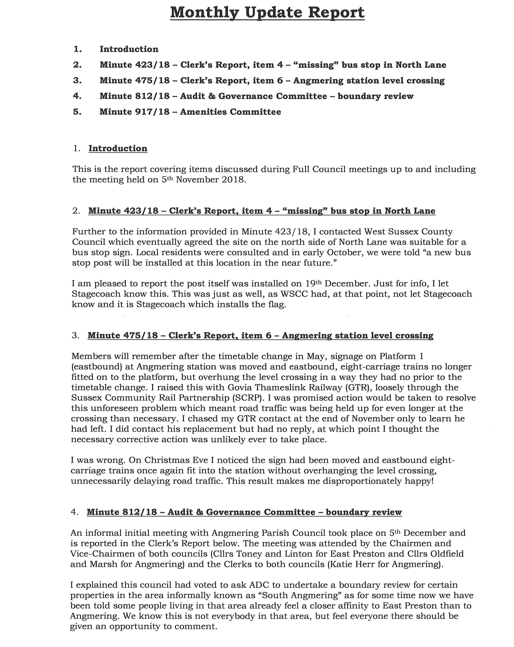
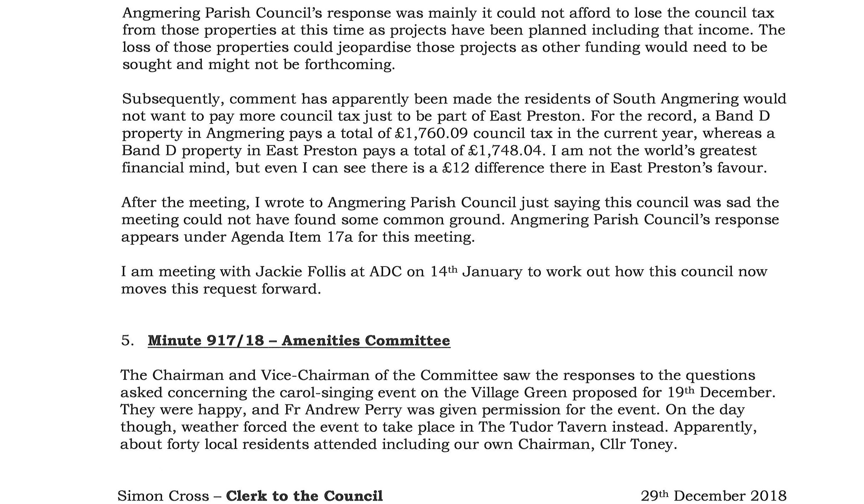

Minute 475/18 – Clerk’s Report, item 6 – Angmering station level crossing – Cllr Linton offered a vote of thanks to the Clerk for his determination in resolving this situation which would have gone unnoticed and un-tackled by most people.

013/19 FINANCIAL MATTERS

The Accounts for December 2018 had been distributed to Members in advance of the meeting.

1267 The council RESOLVED to approve the outstanding Purchase Orders report for 2018/19, value £13,581.35 (excl. VAT).

1268 The council RESOLVED to approve the Supplier Non BACS Invoices Paid report for November Late Payments 2018, totalling £113.08 (incl. VAT).

1269 The council RESOLVED to approve the Supplier Non BACS Invoices Paid report for December 2018, totalling £1,362.91 (incl. VAT).

1270 The council RESOLVED to approve the Supplier BACS Invoices Paid report for December 2018 totalling £13,247.60 (incl. VAT).

1271 The council RESOLVED to approve the List of Sales Receipts & Bank Receipts by Bank report, showing £281,320.27 (incl. VAT) for the financial year ending 31st March 2019.

The council NOTED the paper Bank Reconciliations to 14th December 2018.

The council NOTED the to-date Income & Expenditure Summary for 2018/19.

The Chairman thanked the council’s Book-keeper, Mrs Khoo, for her work on the above reports.

The following report, covering the next two items, had been circulated in advance of the meeting:

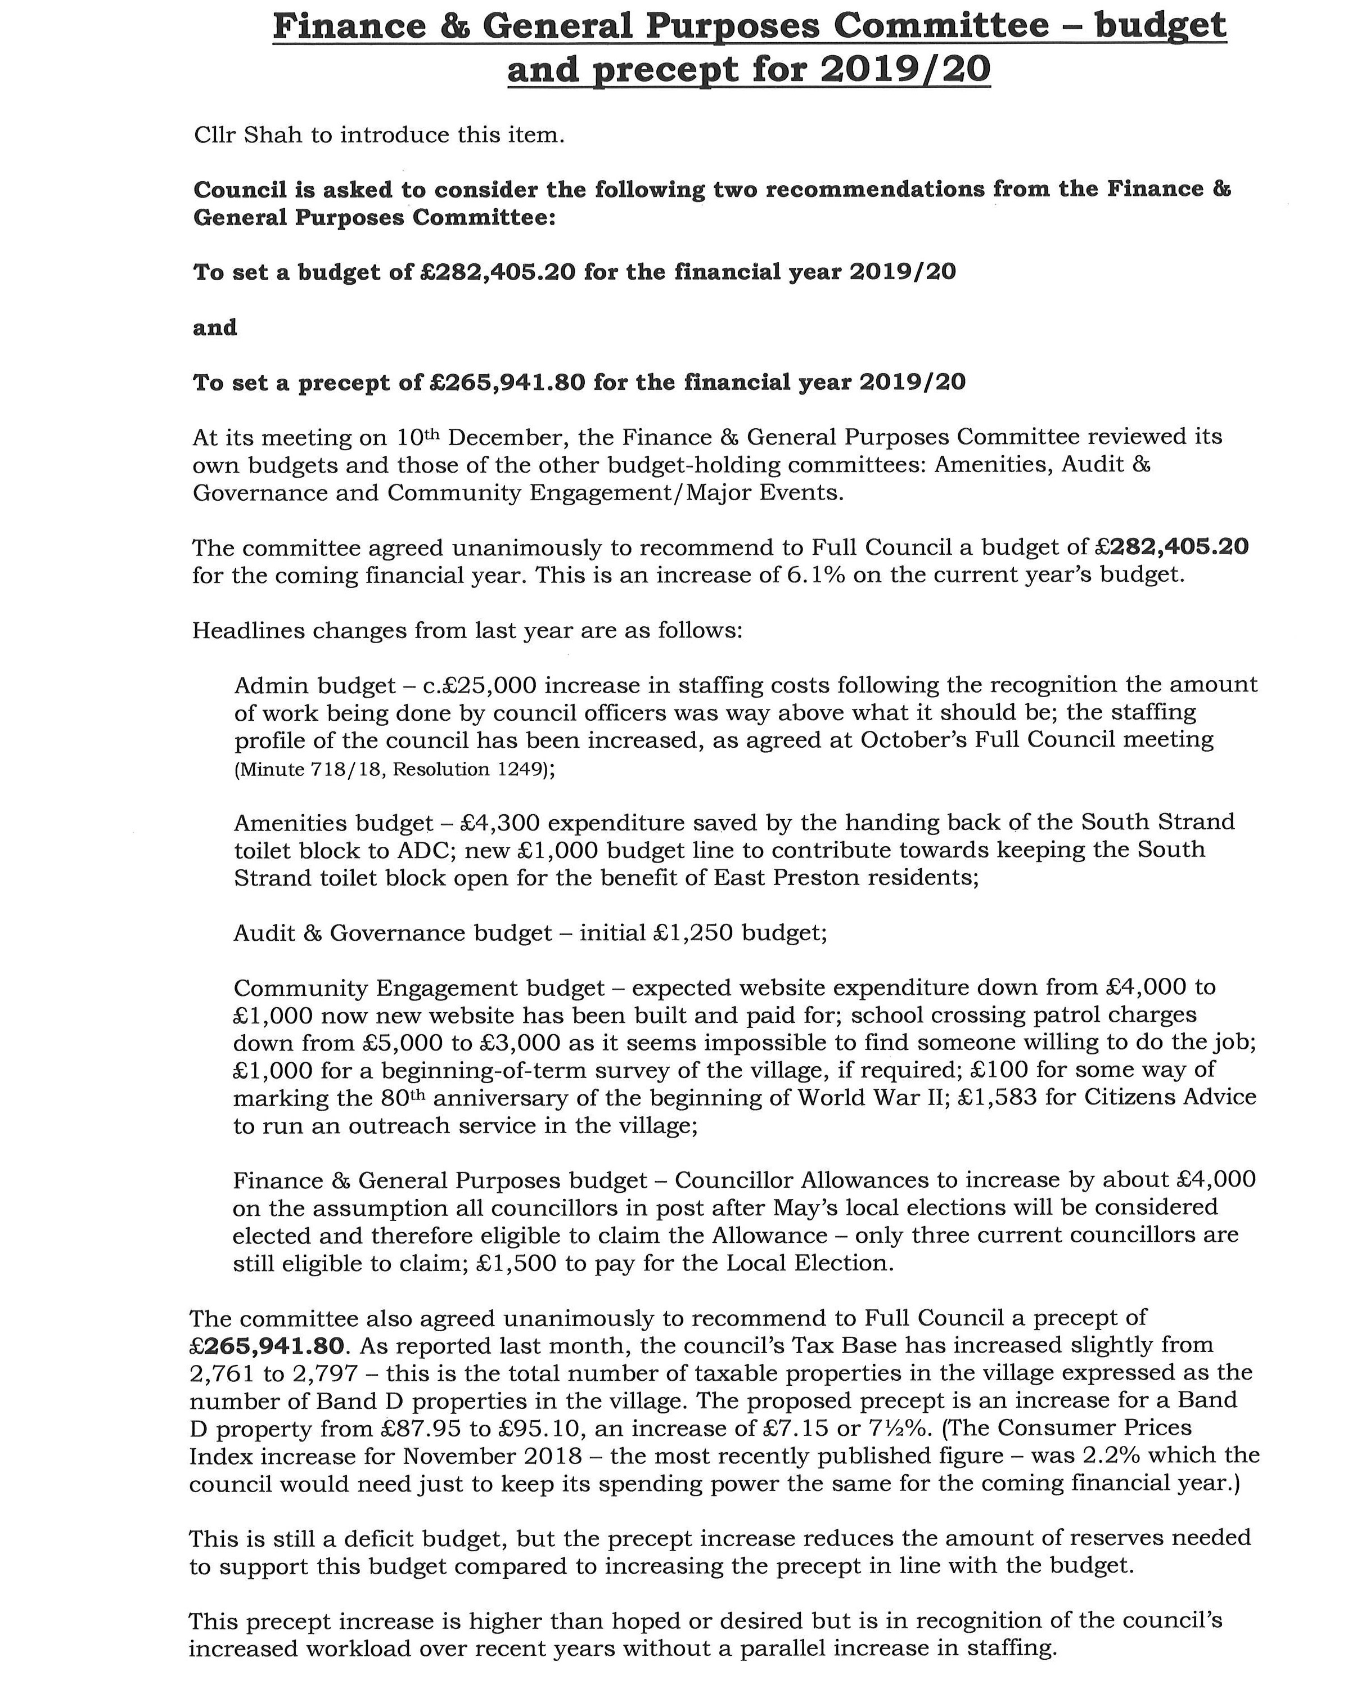



014/19 FINANCE & GENERAL PURPOSES COMMITTEE – BUDGET FOR 2019/20

The council NOTED the above report.

1272 The council RESOLVED to set the budget for the financial year 2019/20 to £282,405.20.

015/19 FINANCE & GENERAL PURPOSES COMMITTEE – PRECEPT FOR 2019/20

The council also NOTED the following report which had been circulated in advance of the meeting:

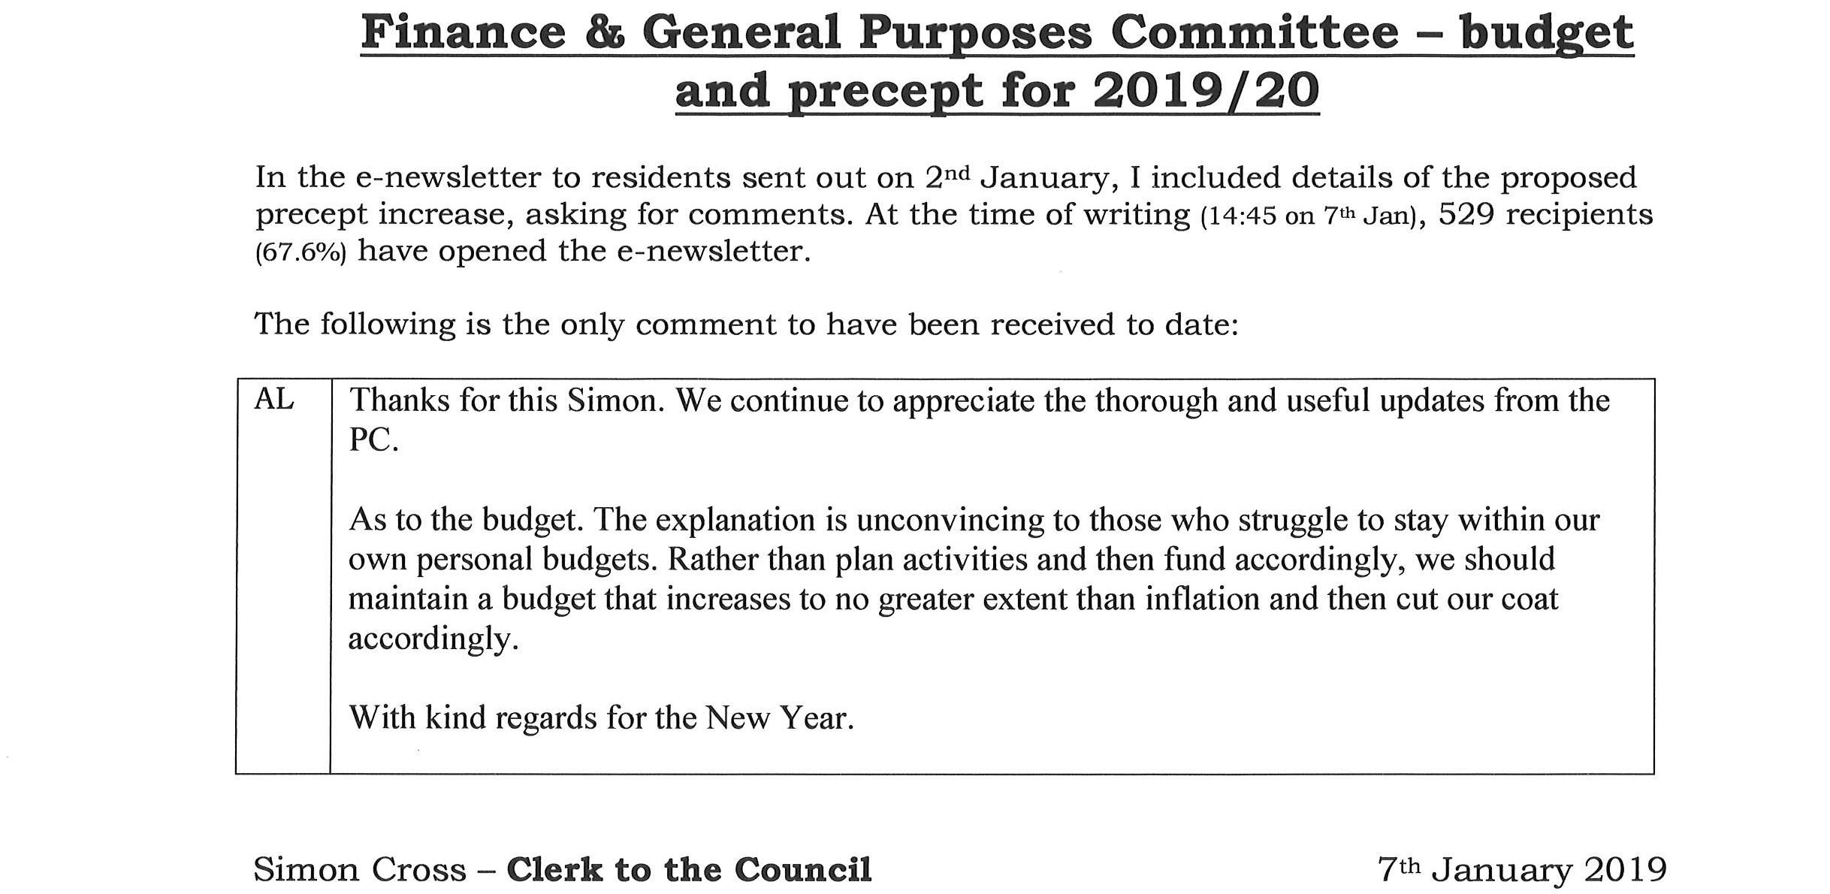

The Clerk advised, as far as it was possible to tell, subscribers to the council’s e-mailing list represented a pretty good cross-section of the population.

1273 The council RESOLVED to set the precept for the financial year 2019/20 to £265,941.80.

016/19 REPORTS FROM PARISH COUNCIL COMMITTEES

The council NOTED the following reports which had been circulated in advance of the meeting:

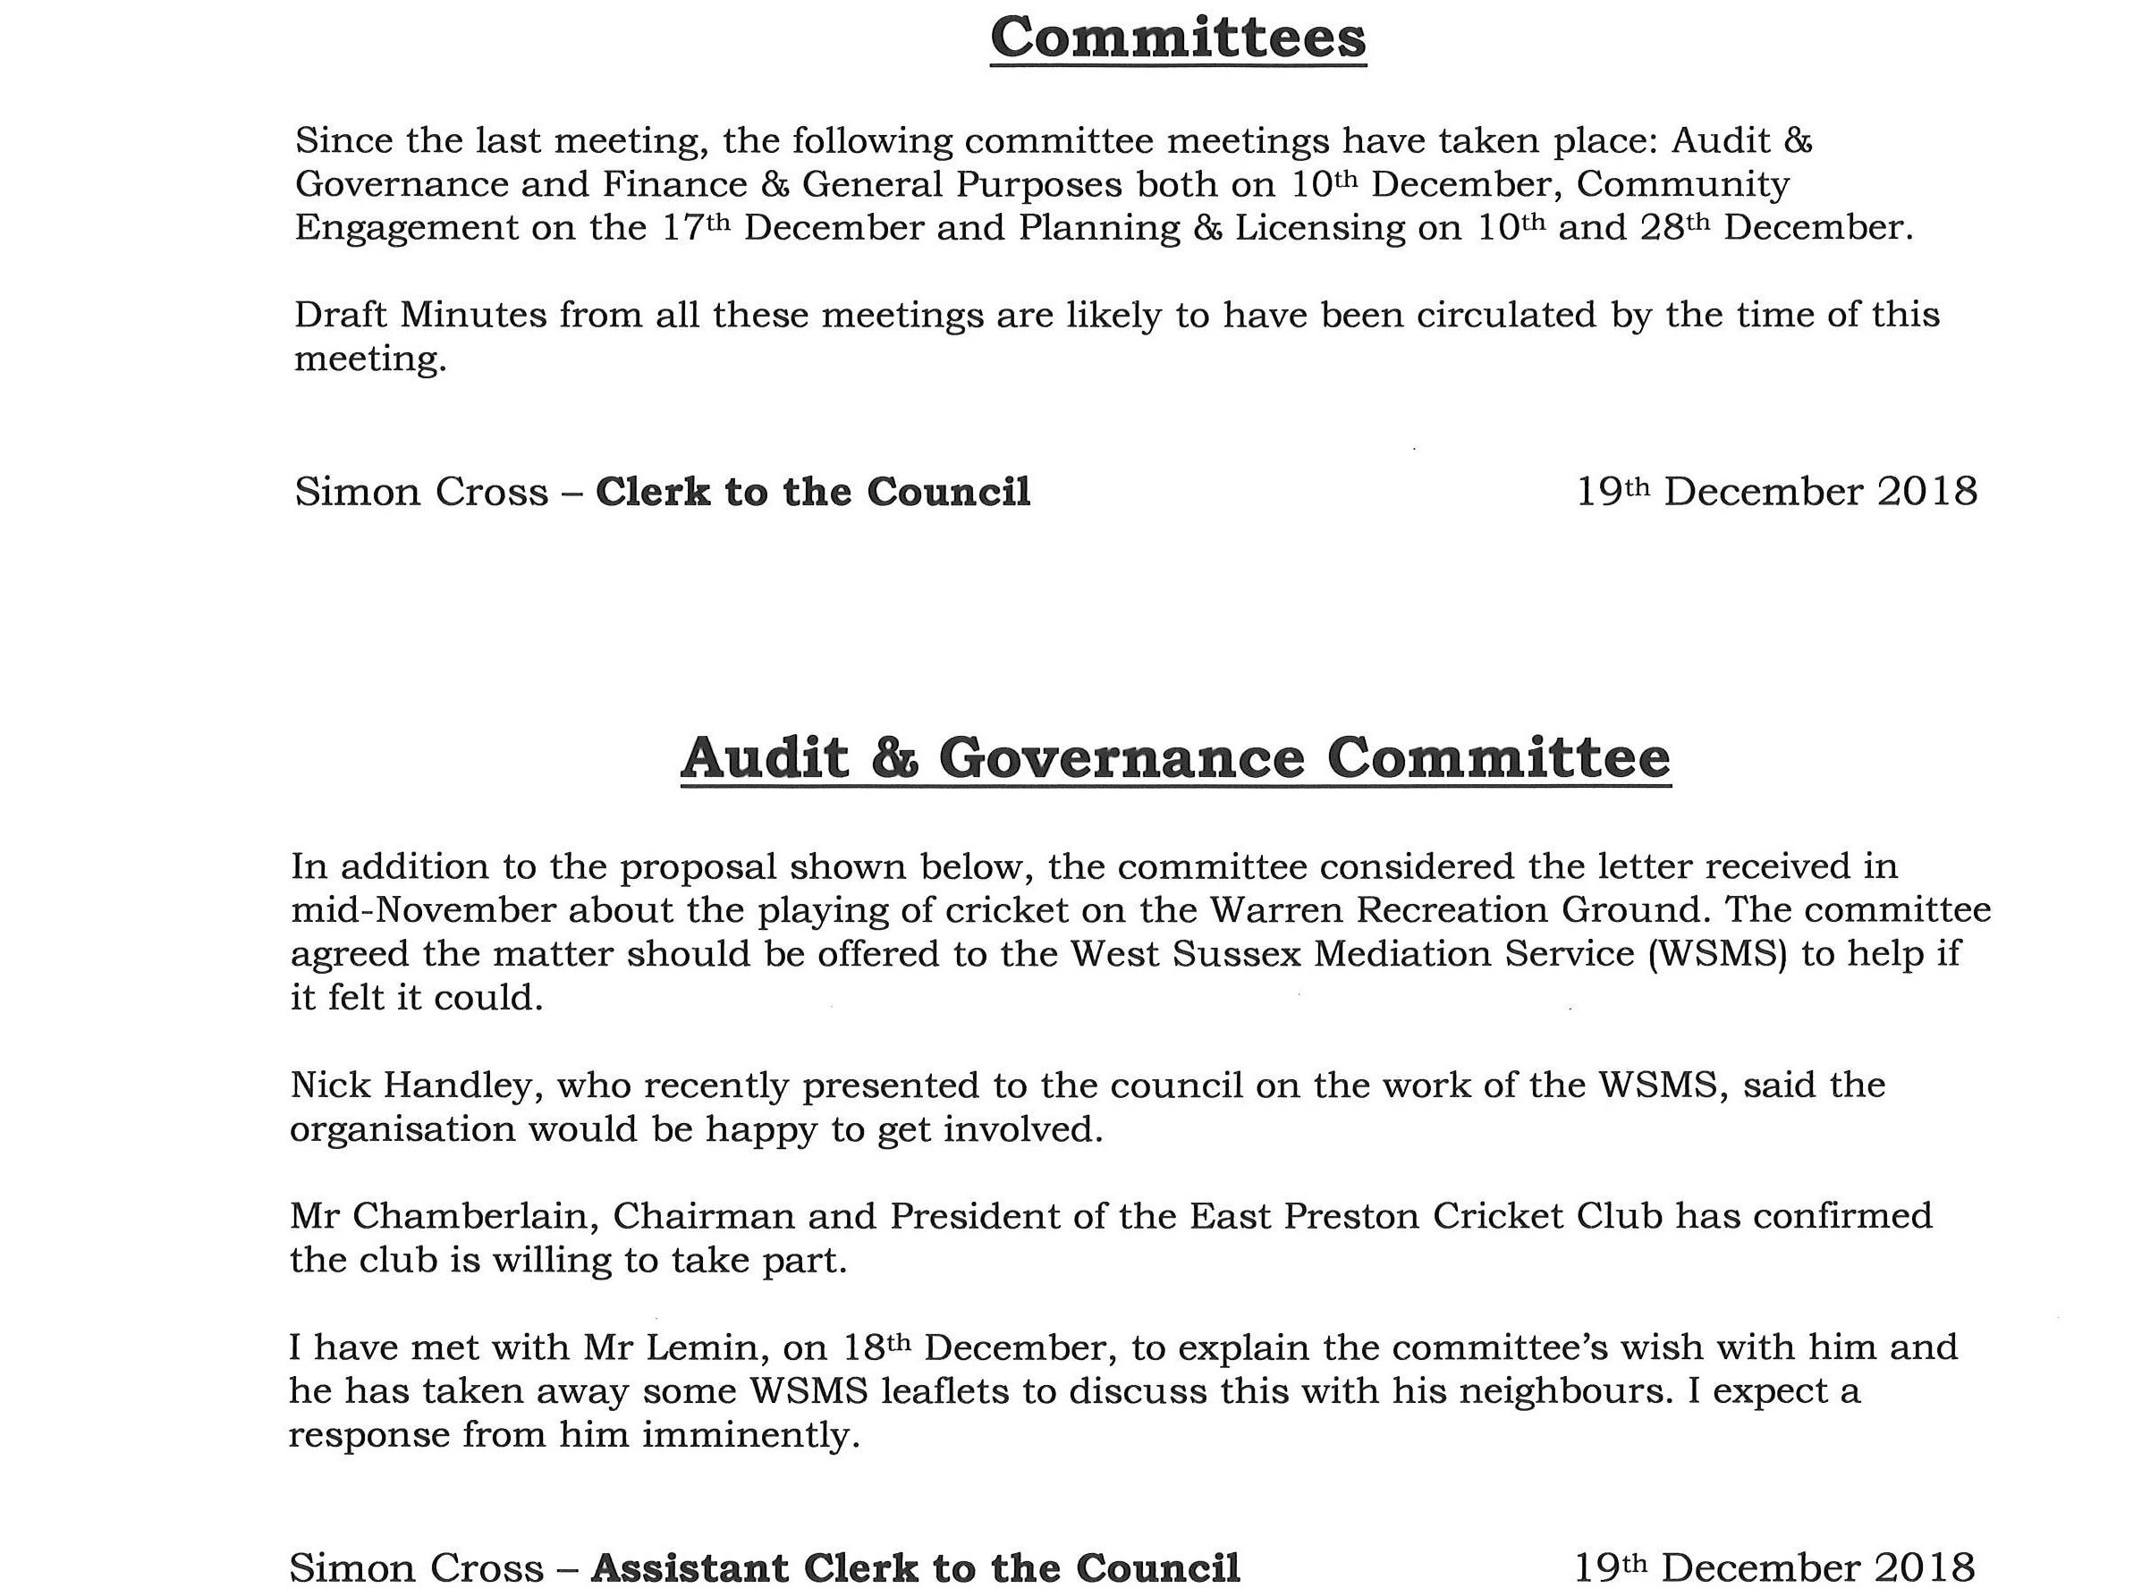

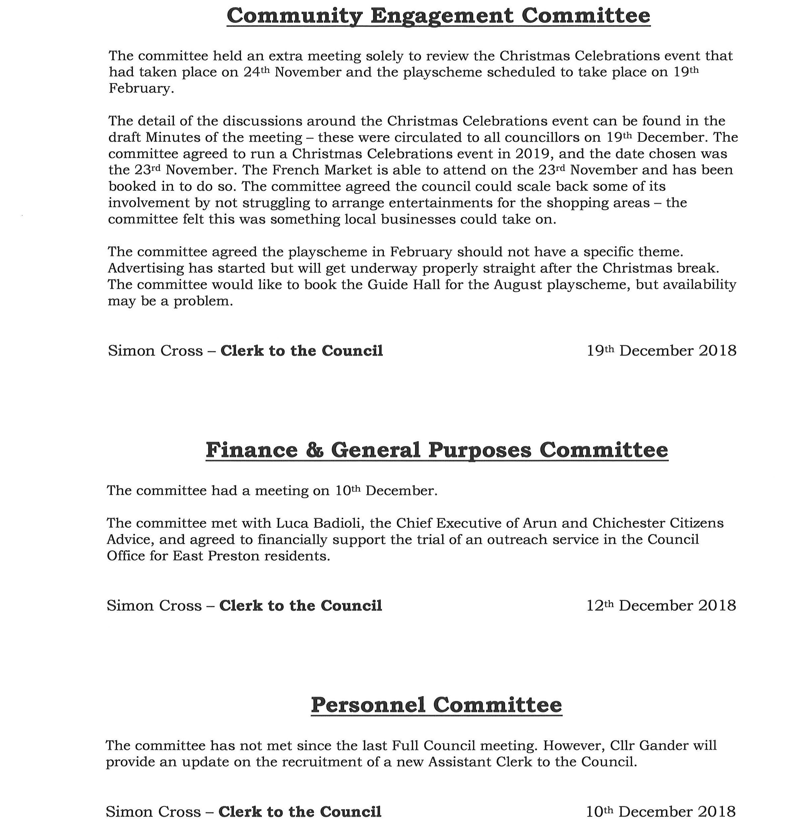

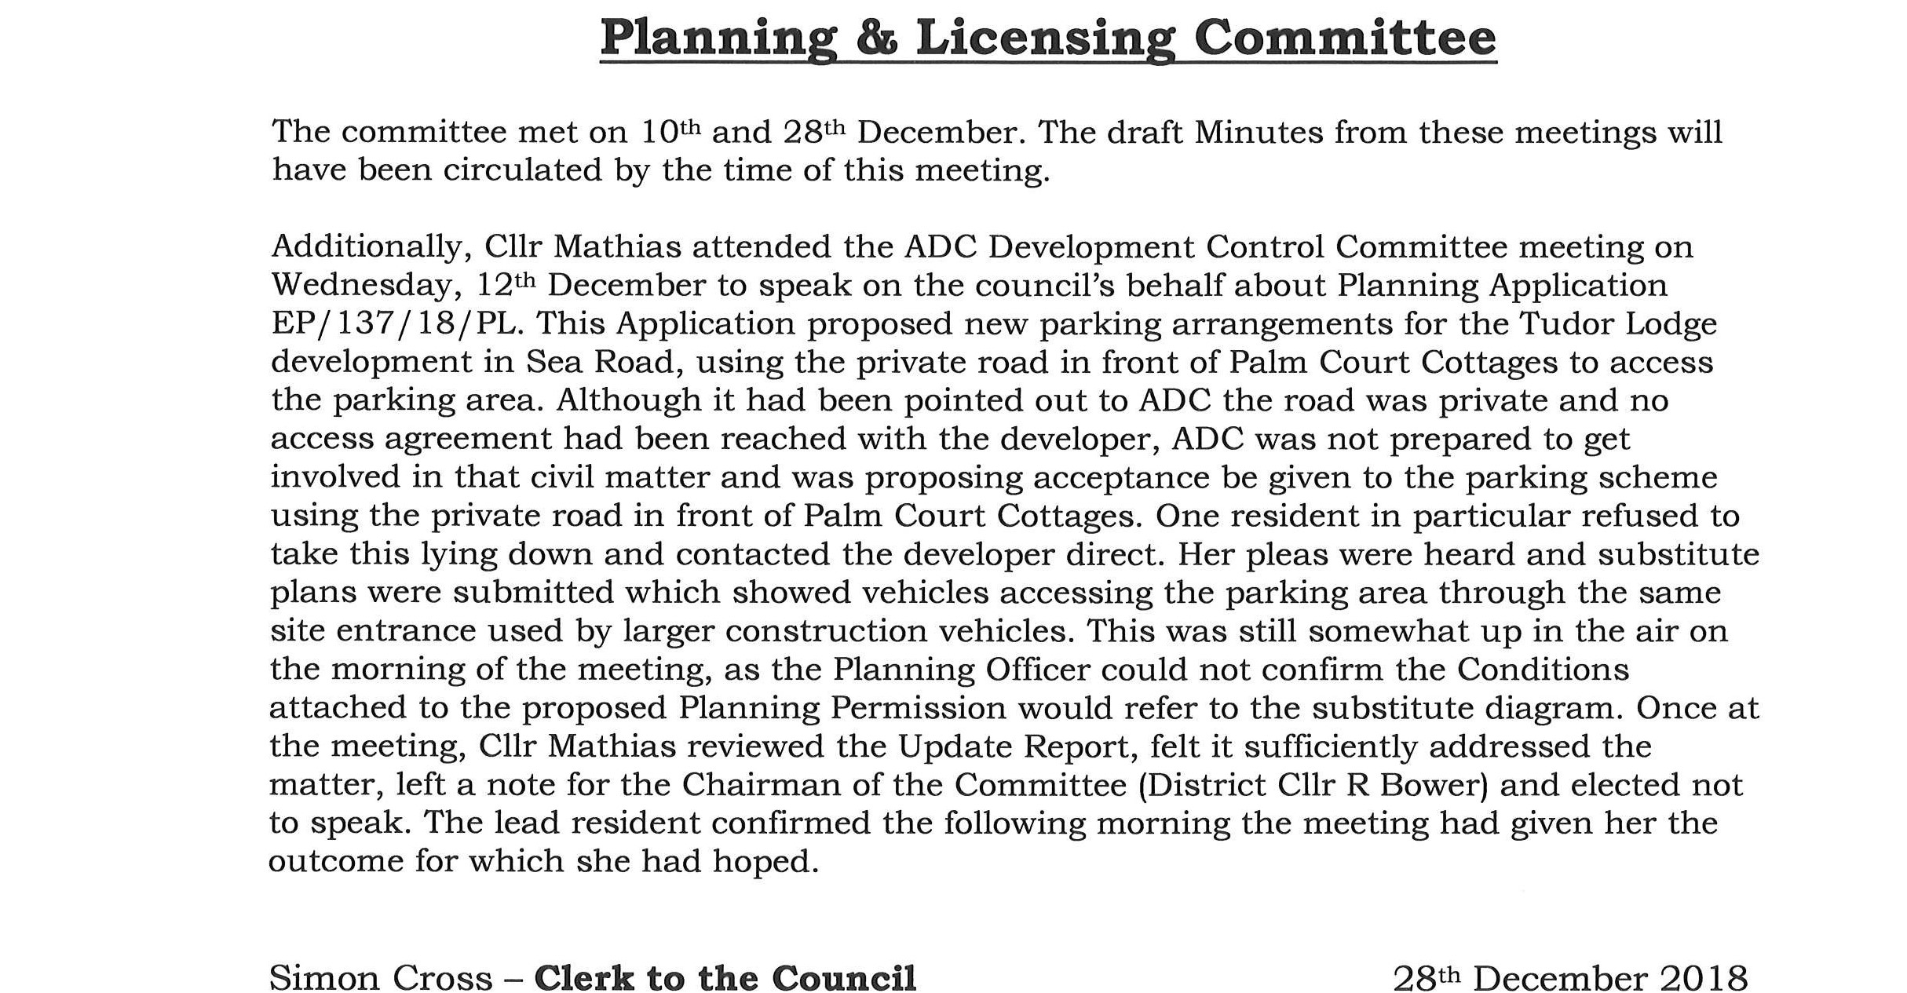

Chairman of the Amenities Committee, Cllr McElroy, reported solar spotlights had been purchased for the Multi-Use Games Area at Lashmar Rec. Work was continuing as to how to install these.

Cllr Linton, Chairman of the Major Events Committee, reported the committee had agreed to run an East Preston Christmas Celebrations event again on 23rd November.

Chairman of the Personnel Committee, Cllr Gander, reported the council had appointed a new Assistant Clerk to the Council, Mrs Dawn Reid, due to start on Monday, 21st January. Mrs Reid would initially be working twenty hours per week. Cllr Gander reported the interview panel felt Mrs Reid had excellent administrative skills and expected her to fit into the role well. Locum Assistant Clerk, Andy Beams, will continue with the council until the end of the month and has been a valuable resource.

Cllr Mathias, Chairman of the Planning & Licensing Committee, said the forthcoming committee meeting on 14th January could be interesting as it would be considering Applications for the sail loft at the bottom of Sea Road, the site of Gladwyn in The Street, and the plot of land behind Beechlands Cottages in Beechlands Close. Each of these was interesting in a different way.

017/19 AUDIT & GOVERNANCE COMMITTEE – MILLENNIUM WALL-HANGING

The council NOTED the following reports which had been circulated in advance of the meeting:

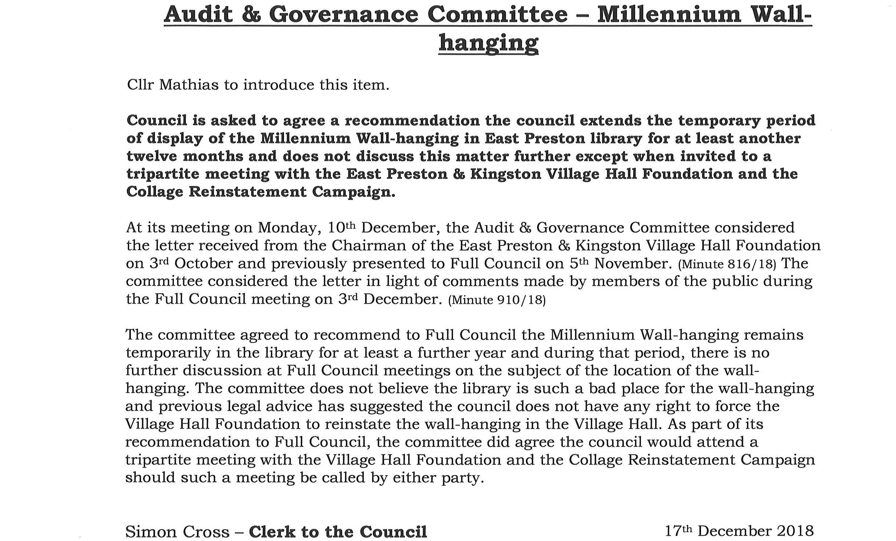



Cllr Mathias advised the committee felt there was not a lot of point in continuing to discuss the wall-hanging and hear the public’s views whilst there was no movement likely on any side. Cllr McElroy said all three parties involved – council, VHF committee and Collage Reinstatement Campaign – needed to talk together in order to make any progress on this.

1274 The council RESOLVED unanimously to agree the council extends the temporary period of display of the Millennium Wall-hanging in East Preston library for at least another twelve months and does not discuss this matter further except when invited to a tripartite meeting with the East Preston & Kingston Village Hall Foundation and the Collage Reinstatement Campaign.

018/19 AUDIT & GOVERNANCE COMMITTEE – BOUNDARY REVIEW

The council NOTED the following reports which had been circulated in advance of the meeting:

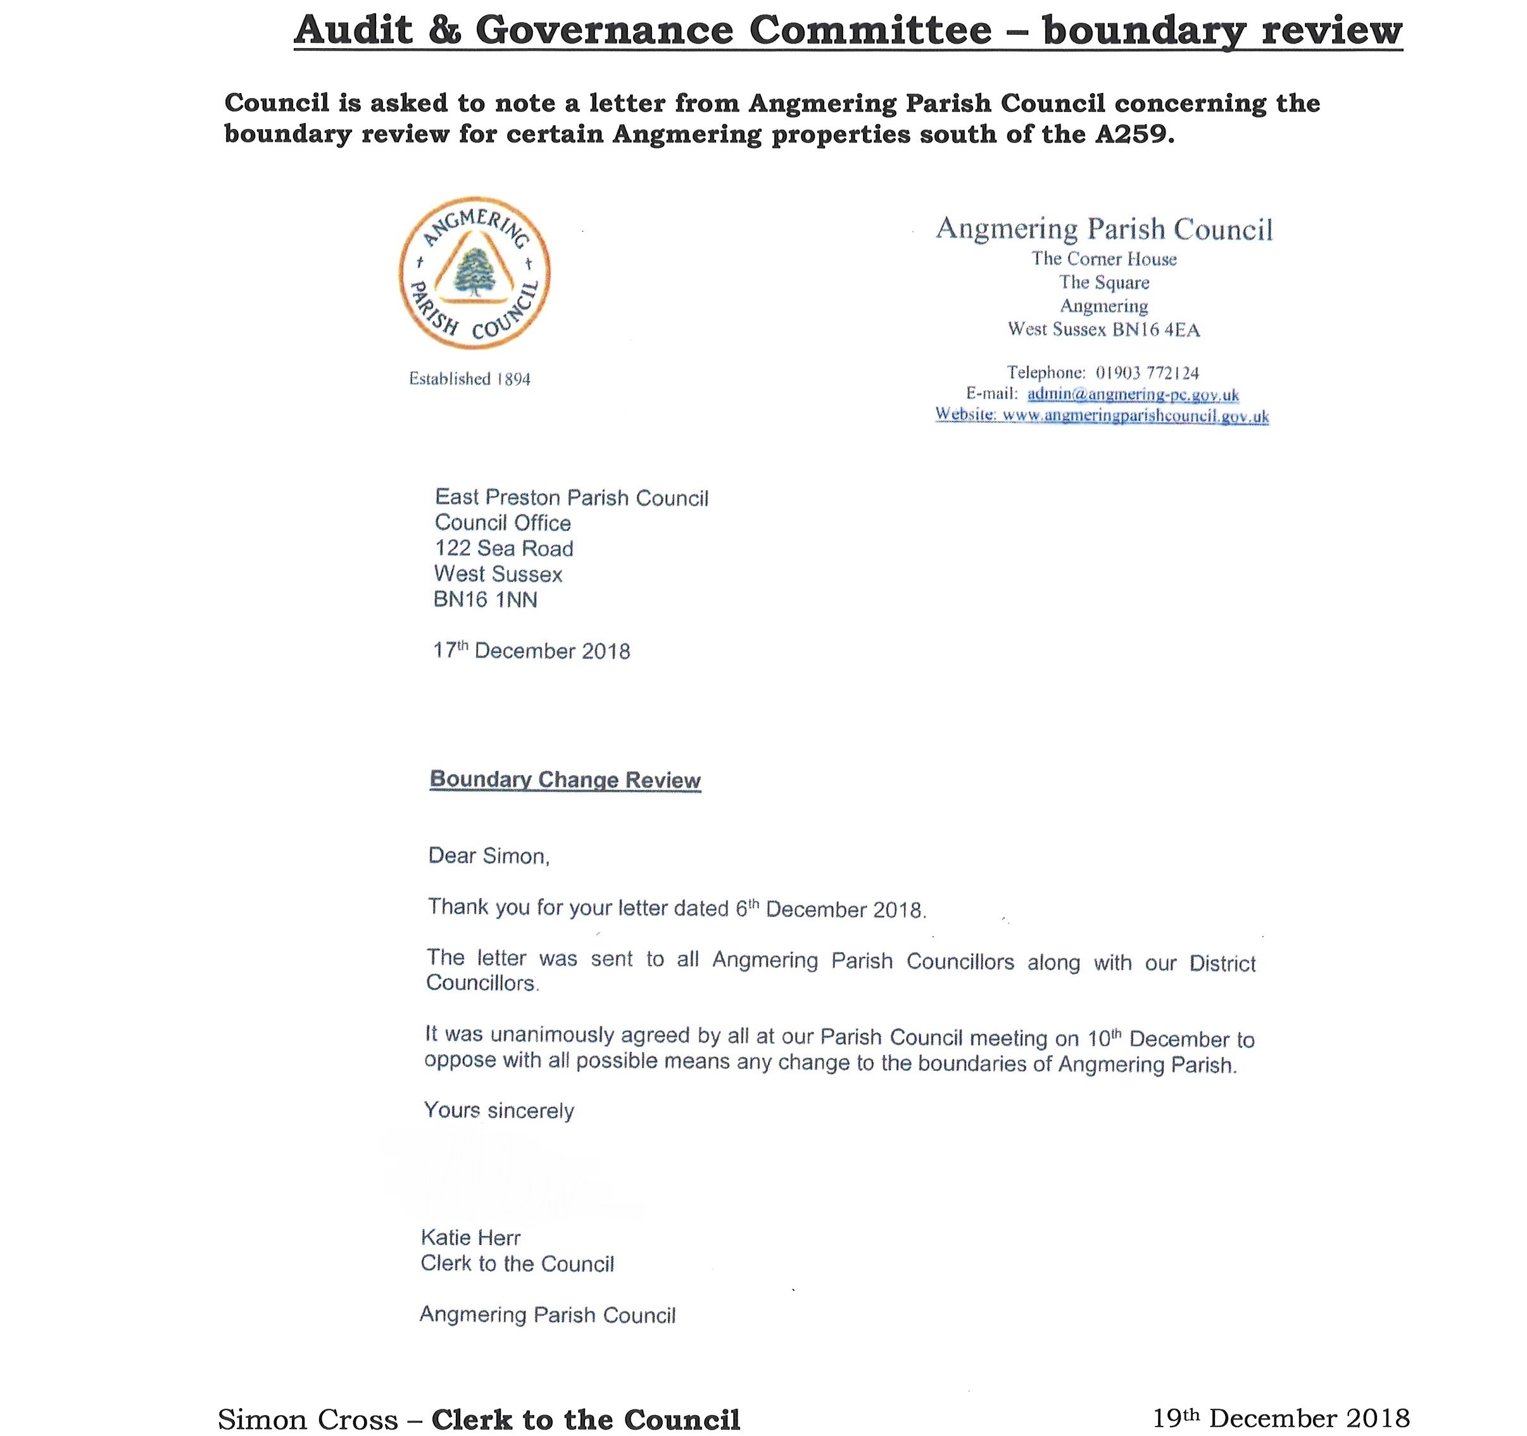

The council will continue in its bid to have ADC carry out a boundary review of the properties in question.

019/19 SOUTH STRAND PUBLIC TOILETS

The council NOTED the following reports which had been circulated in advance of the meeting:

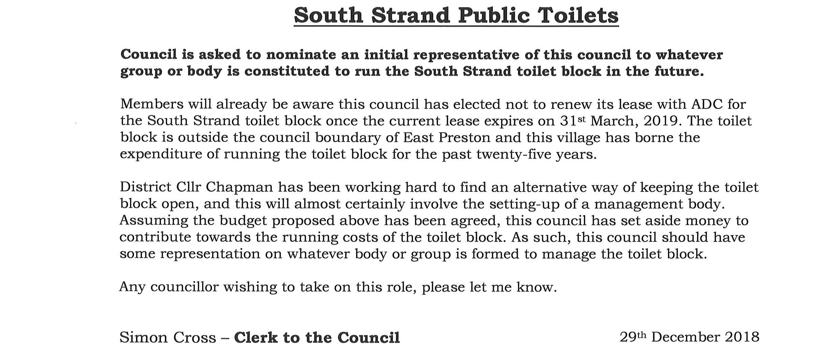

Cllr Wilkinson volunteered on the understanding should there be any conflict of interest between the council and the Angmering-on-Sea Estate Residents’ Association, of which he is a board member, he would step down from representing the council first.

1275 The council RESOLVED unanimously Cllr Wilkinson should be the council’s initial representative to any group constituted to run the South Strand toilet block from 1st April 2019.

020/19 CPRE – GATWICK AIRPORT

The council NOTED the following reports which had been circulated in advance of the meeting:

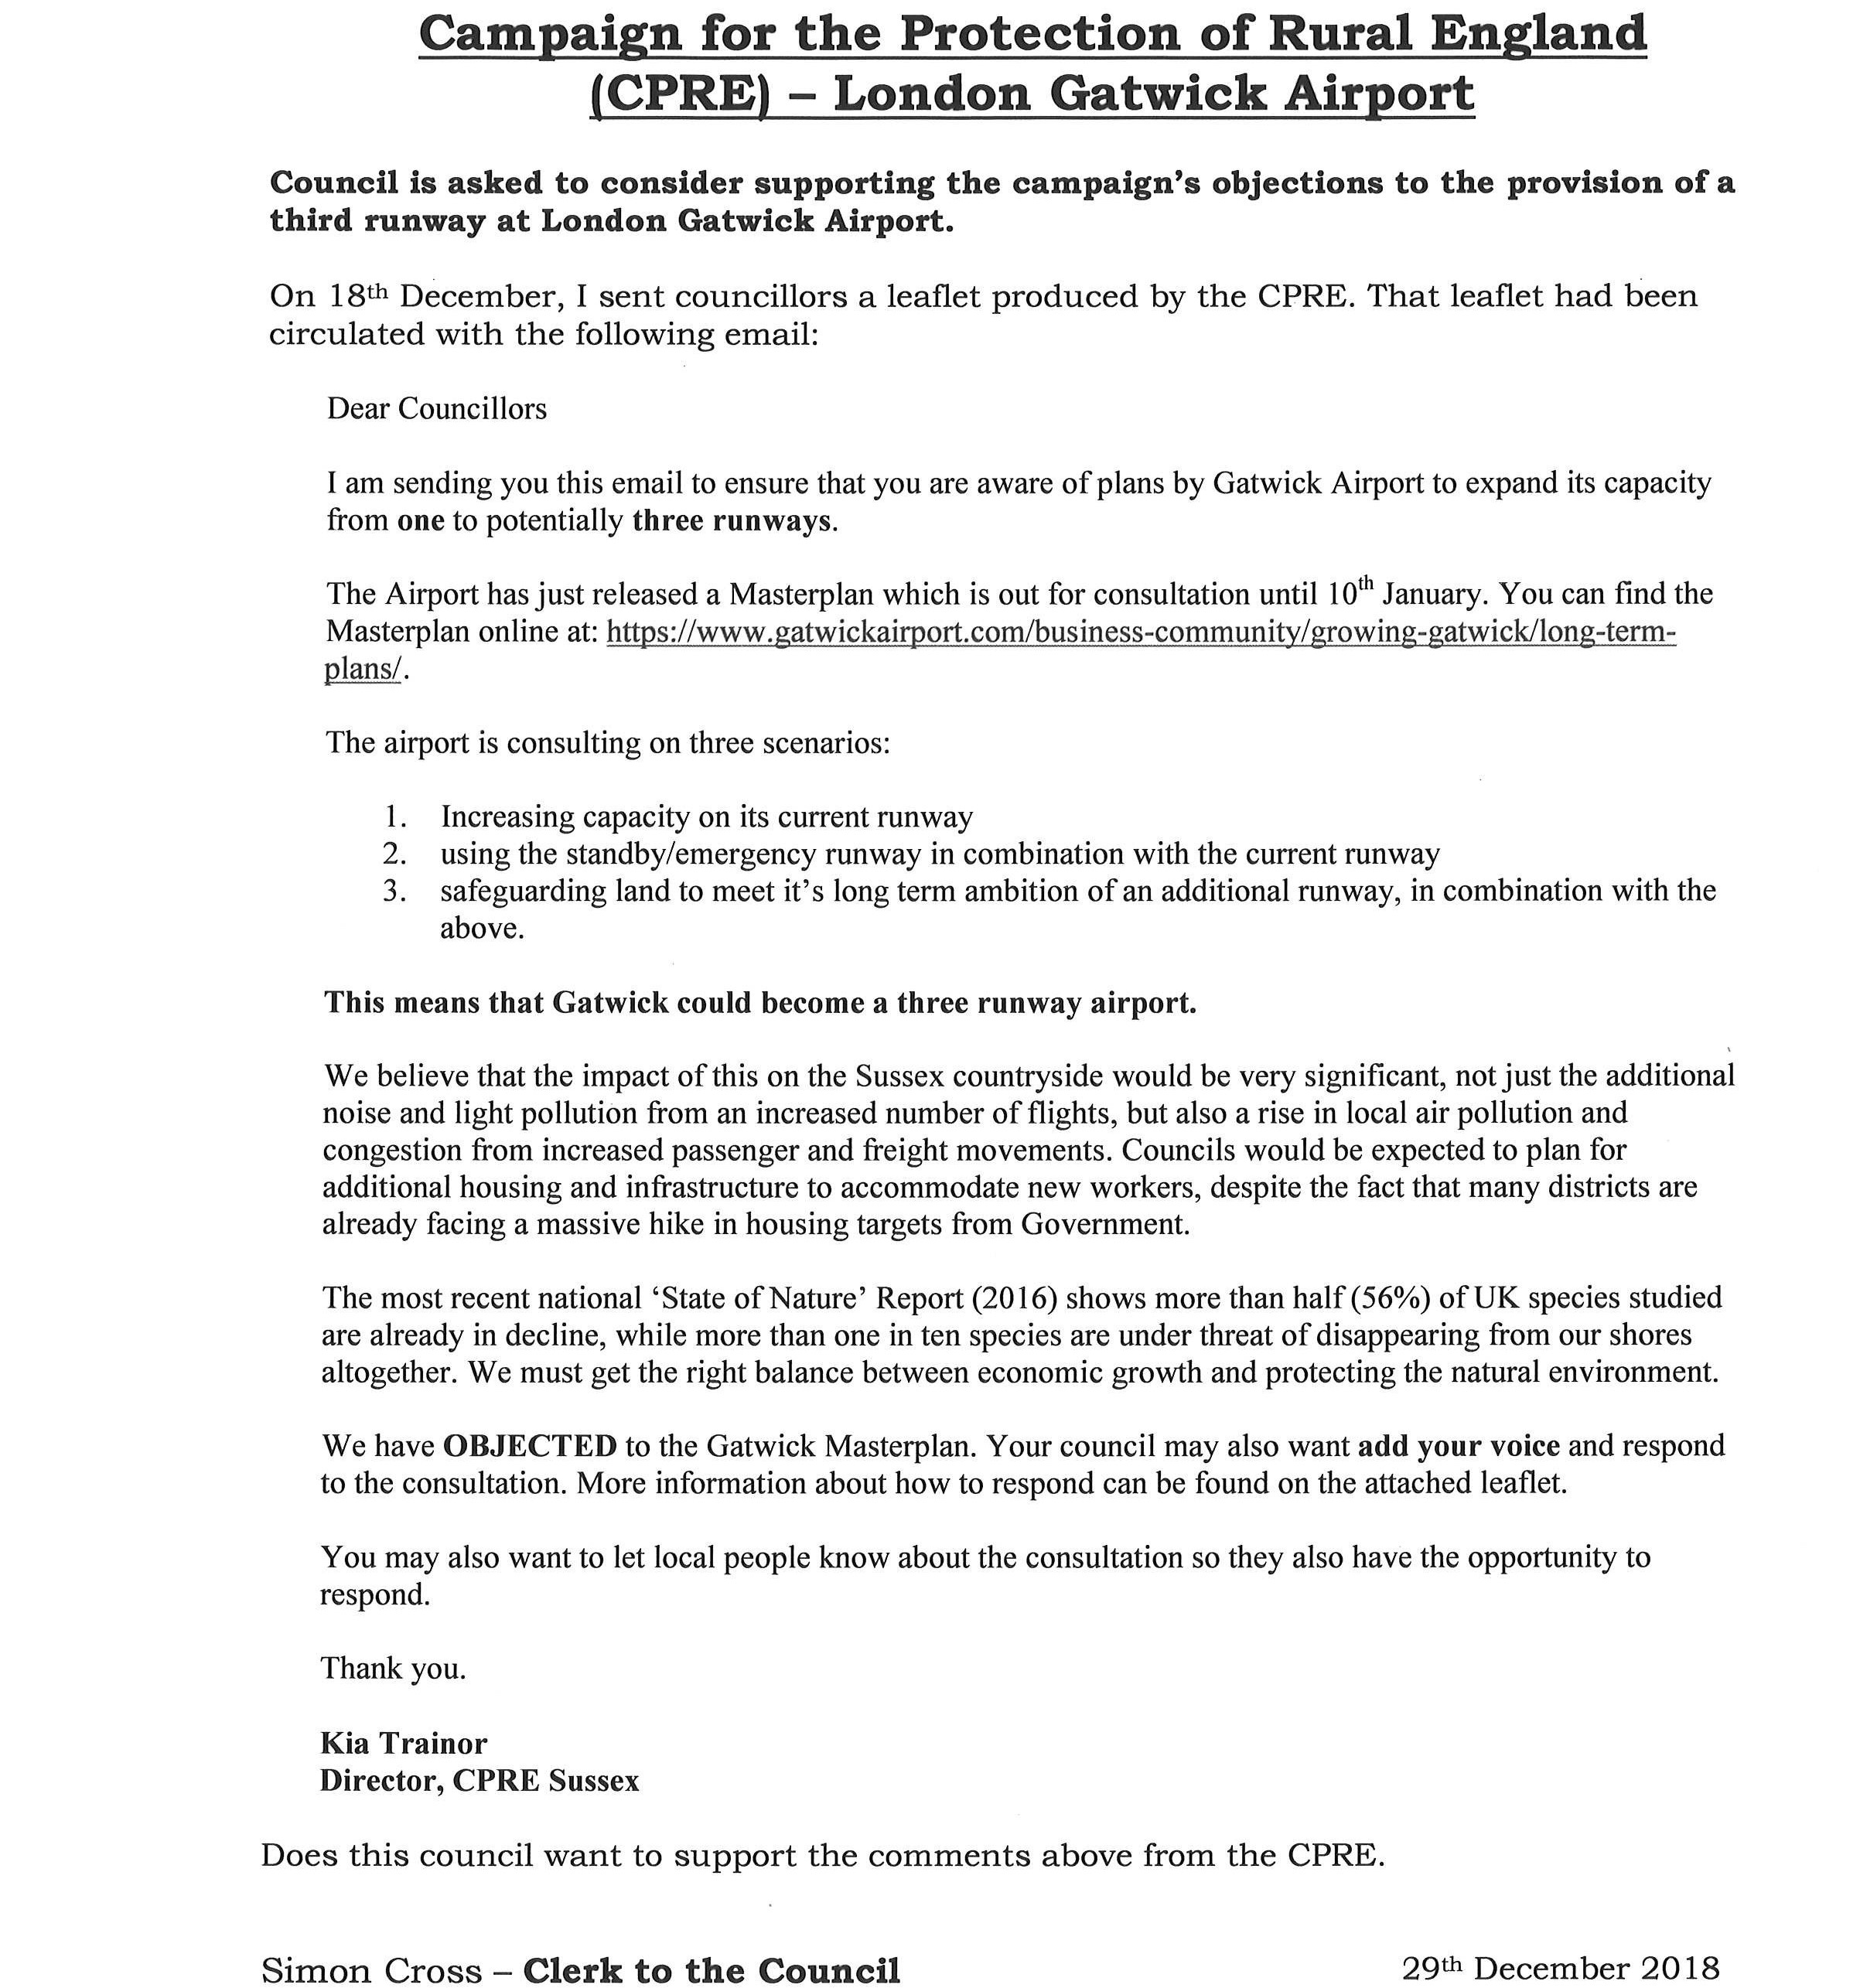

Councillors admitted they felt the report was confusing and not helpful in making a decision. Aside from that, opinion was strongly divided as to the benefits and detriments of Gatwick becoming a three runway airport.

1276 The council RESOLVED not to support the CPRE’s objections to the provision of a third runway at London Gatwick Airport.

(Mrs Wallace left the meeting at the conclusion of this item.)

021/19 REPORTS FROM PARISH COUNCIL WORKING PARTIES

The council NOTED the following report which had been circulated in advance of the meeting:

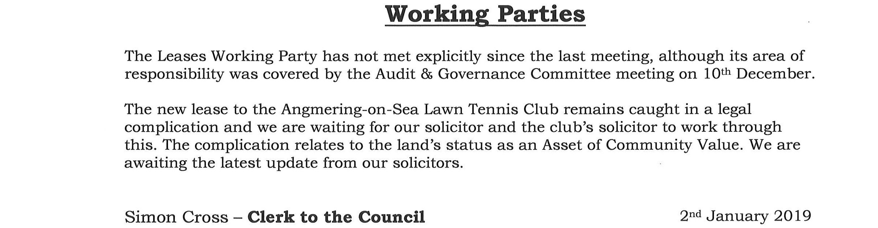

Cllr Mathias reported the Leases Working Party was still waiting for news about the Angmering-on-Sea Lawn Tennis Club lease.

022/19 CLERK’S REPORT

The council NOTED the following report which had been circulated in advance of the meeting:

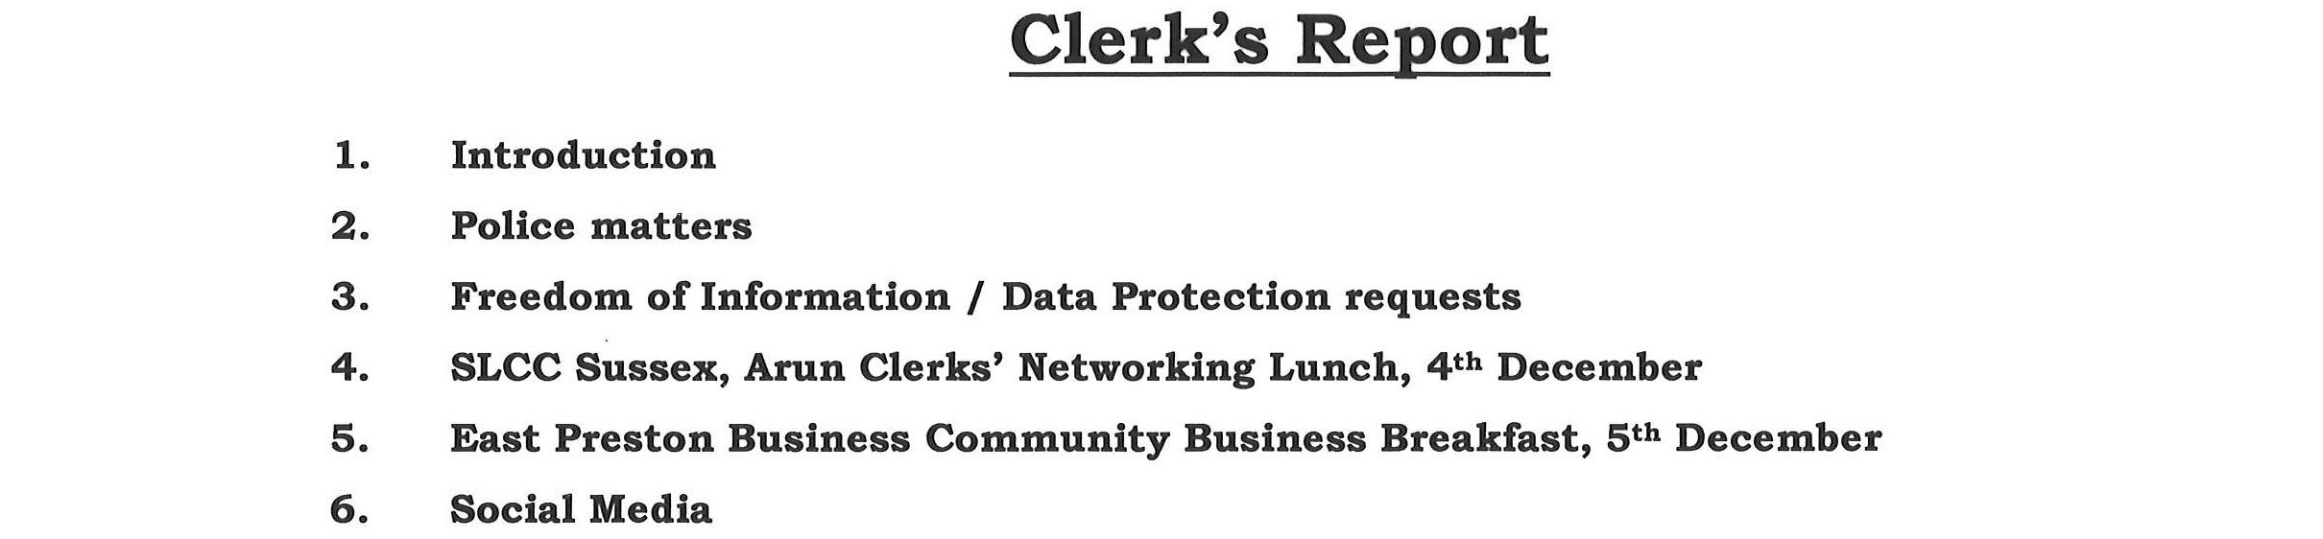

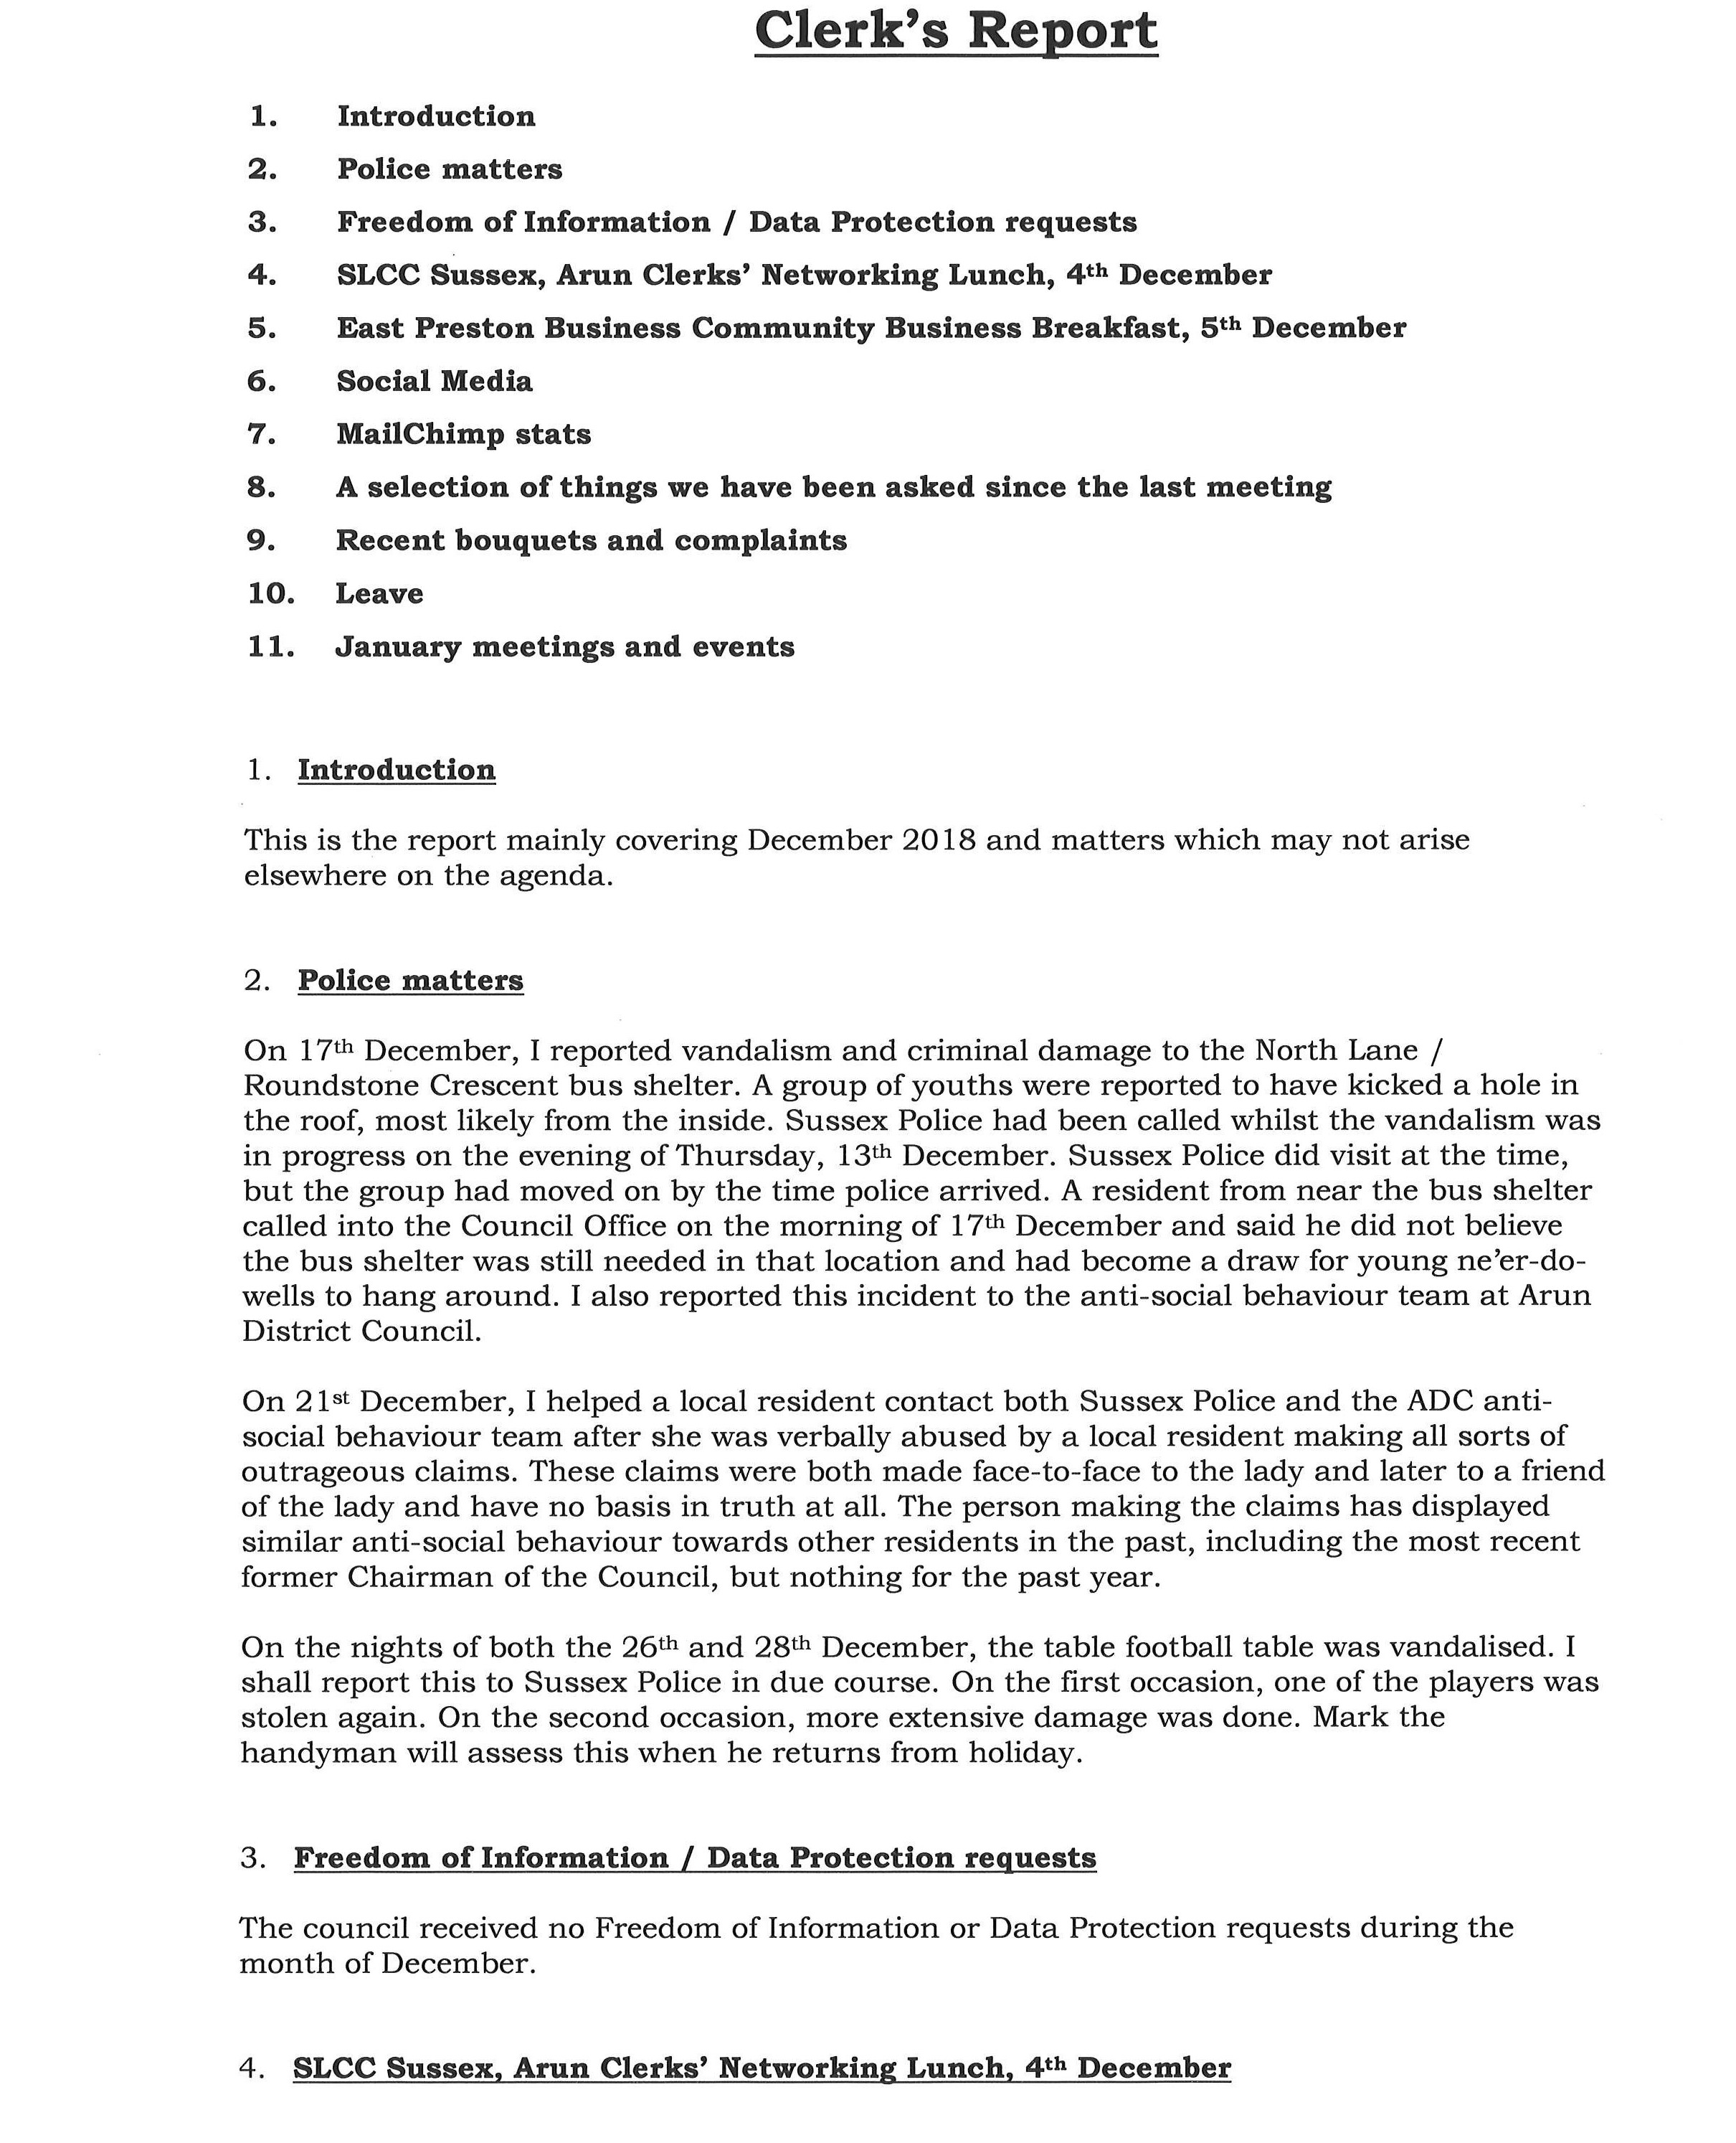
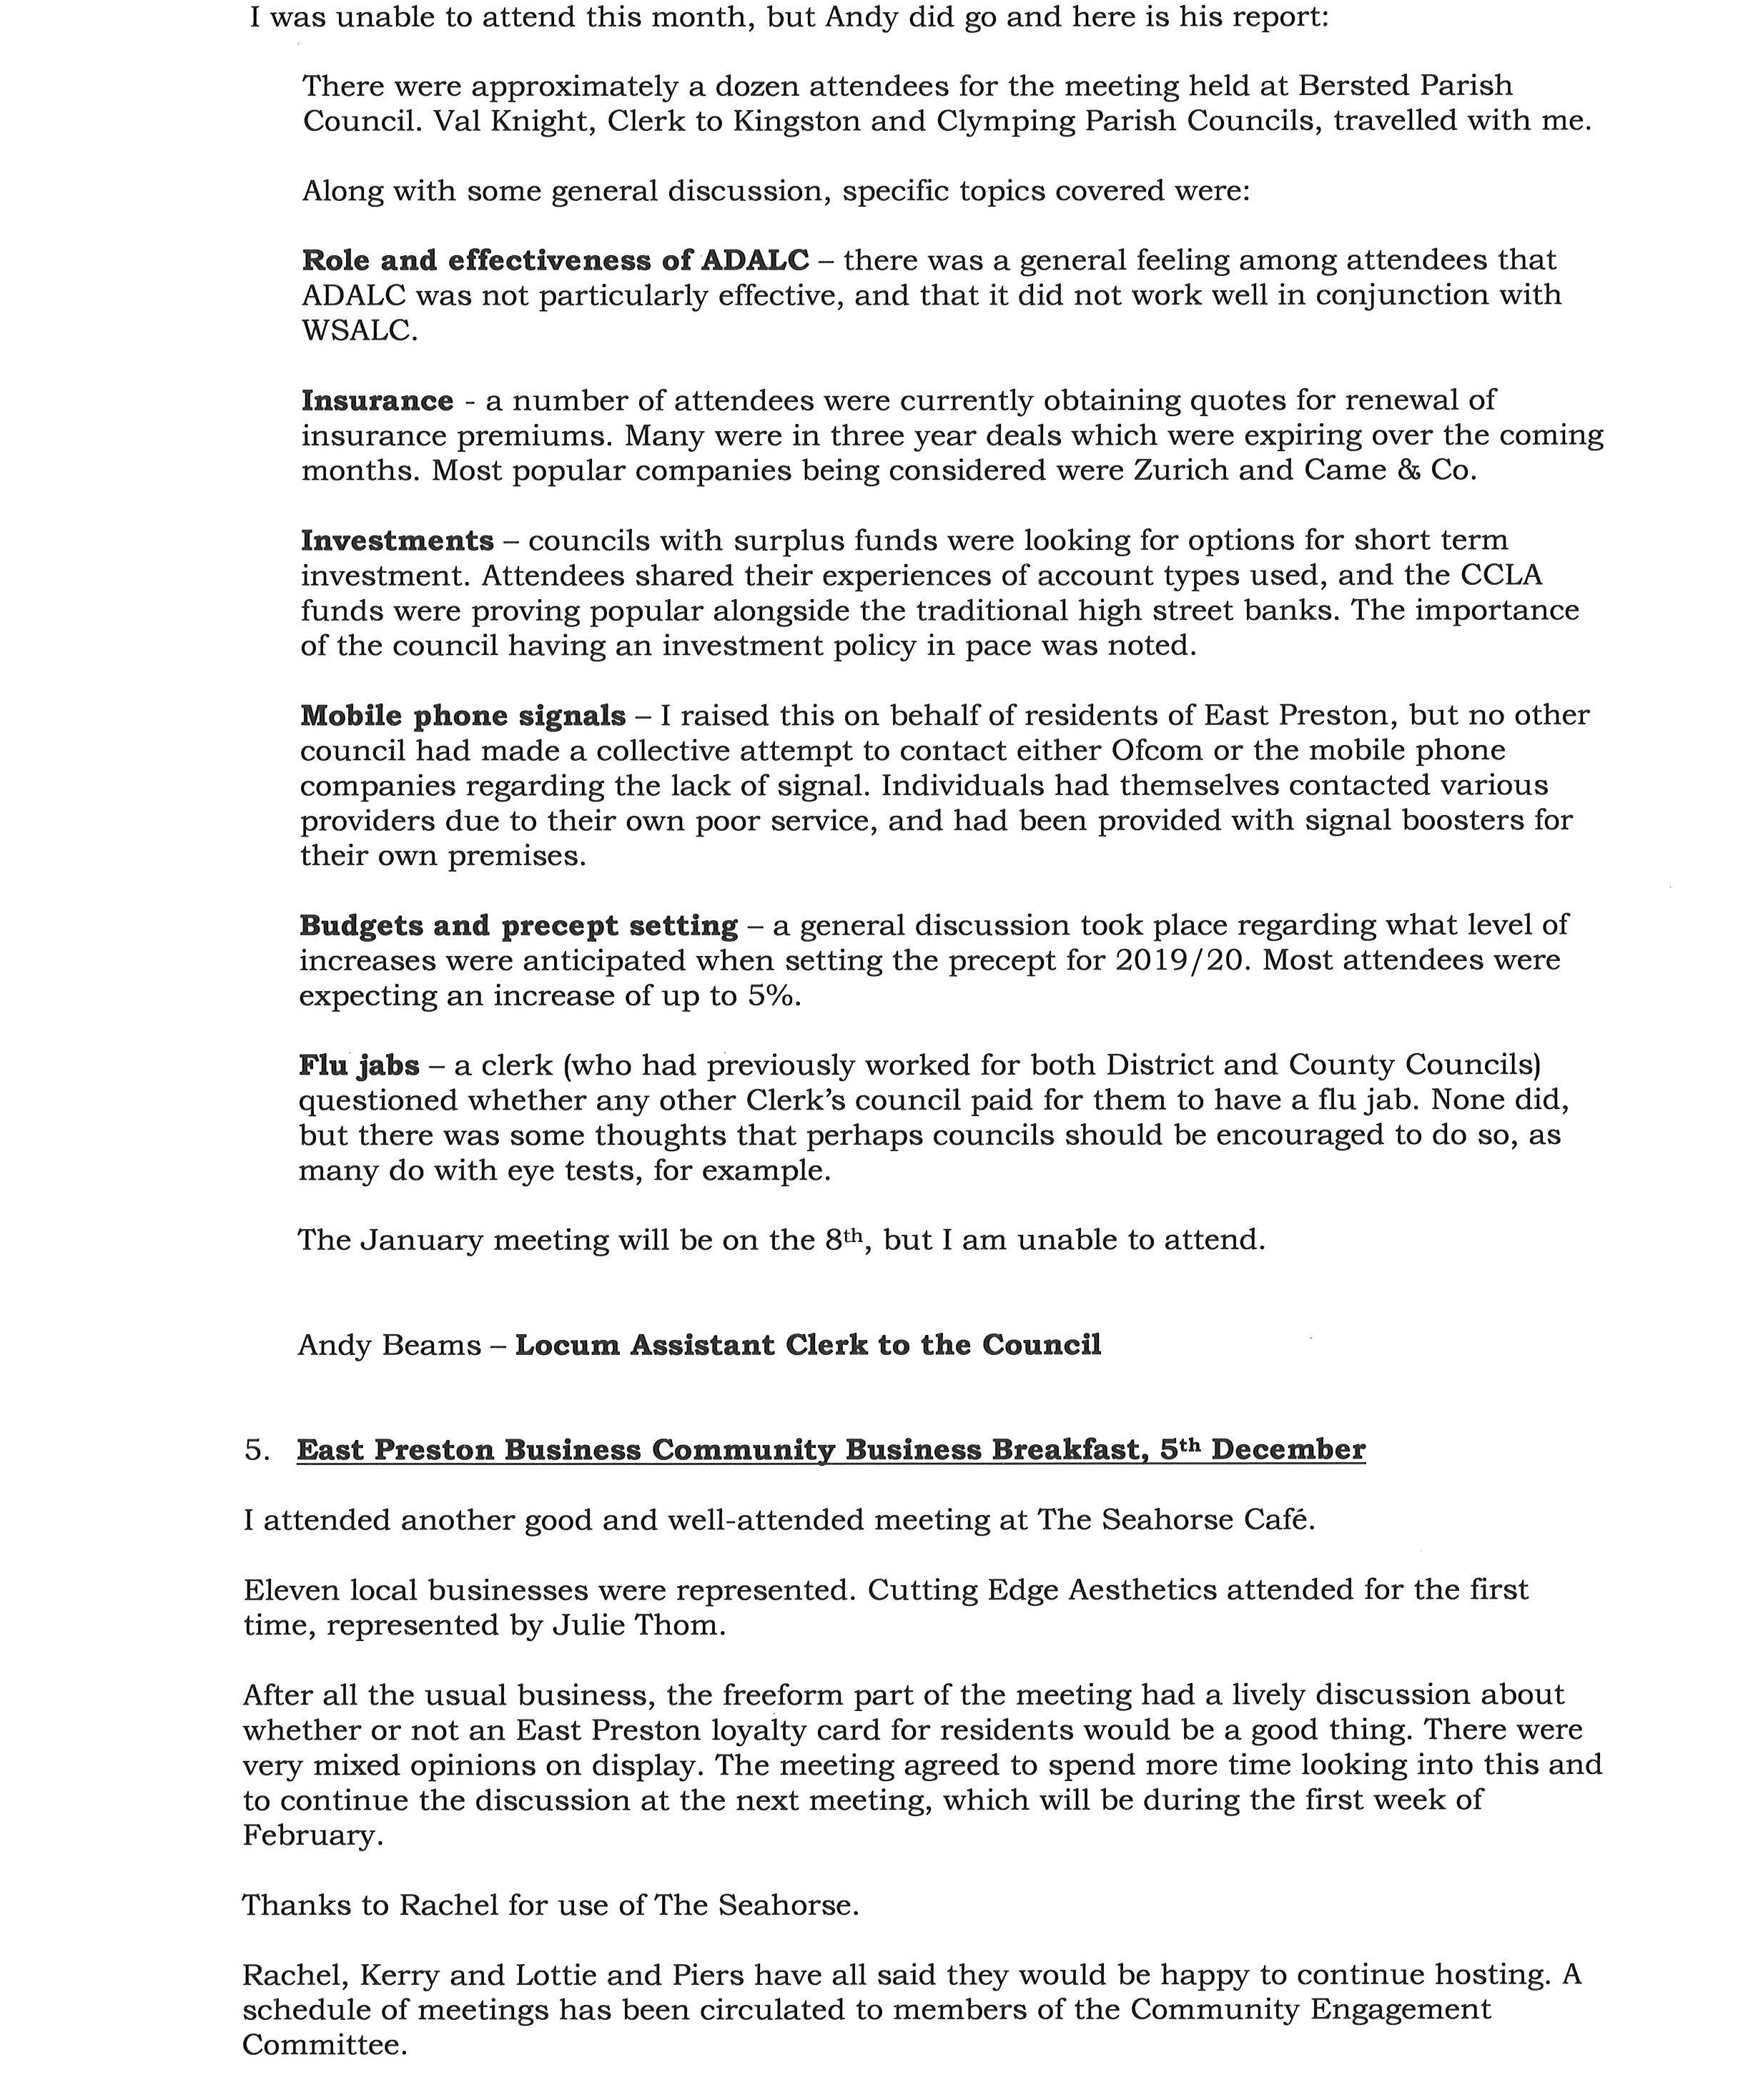

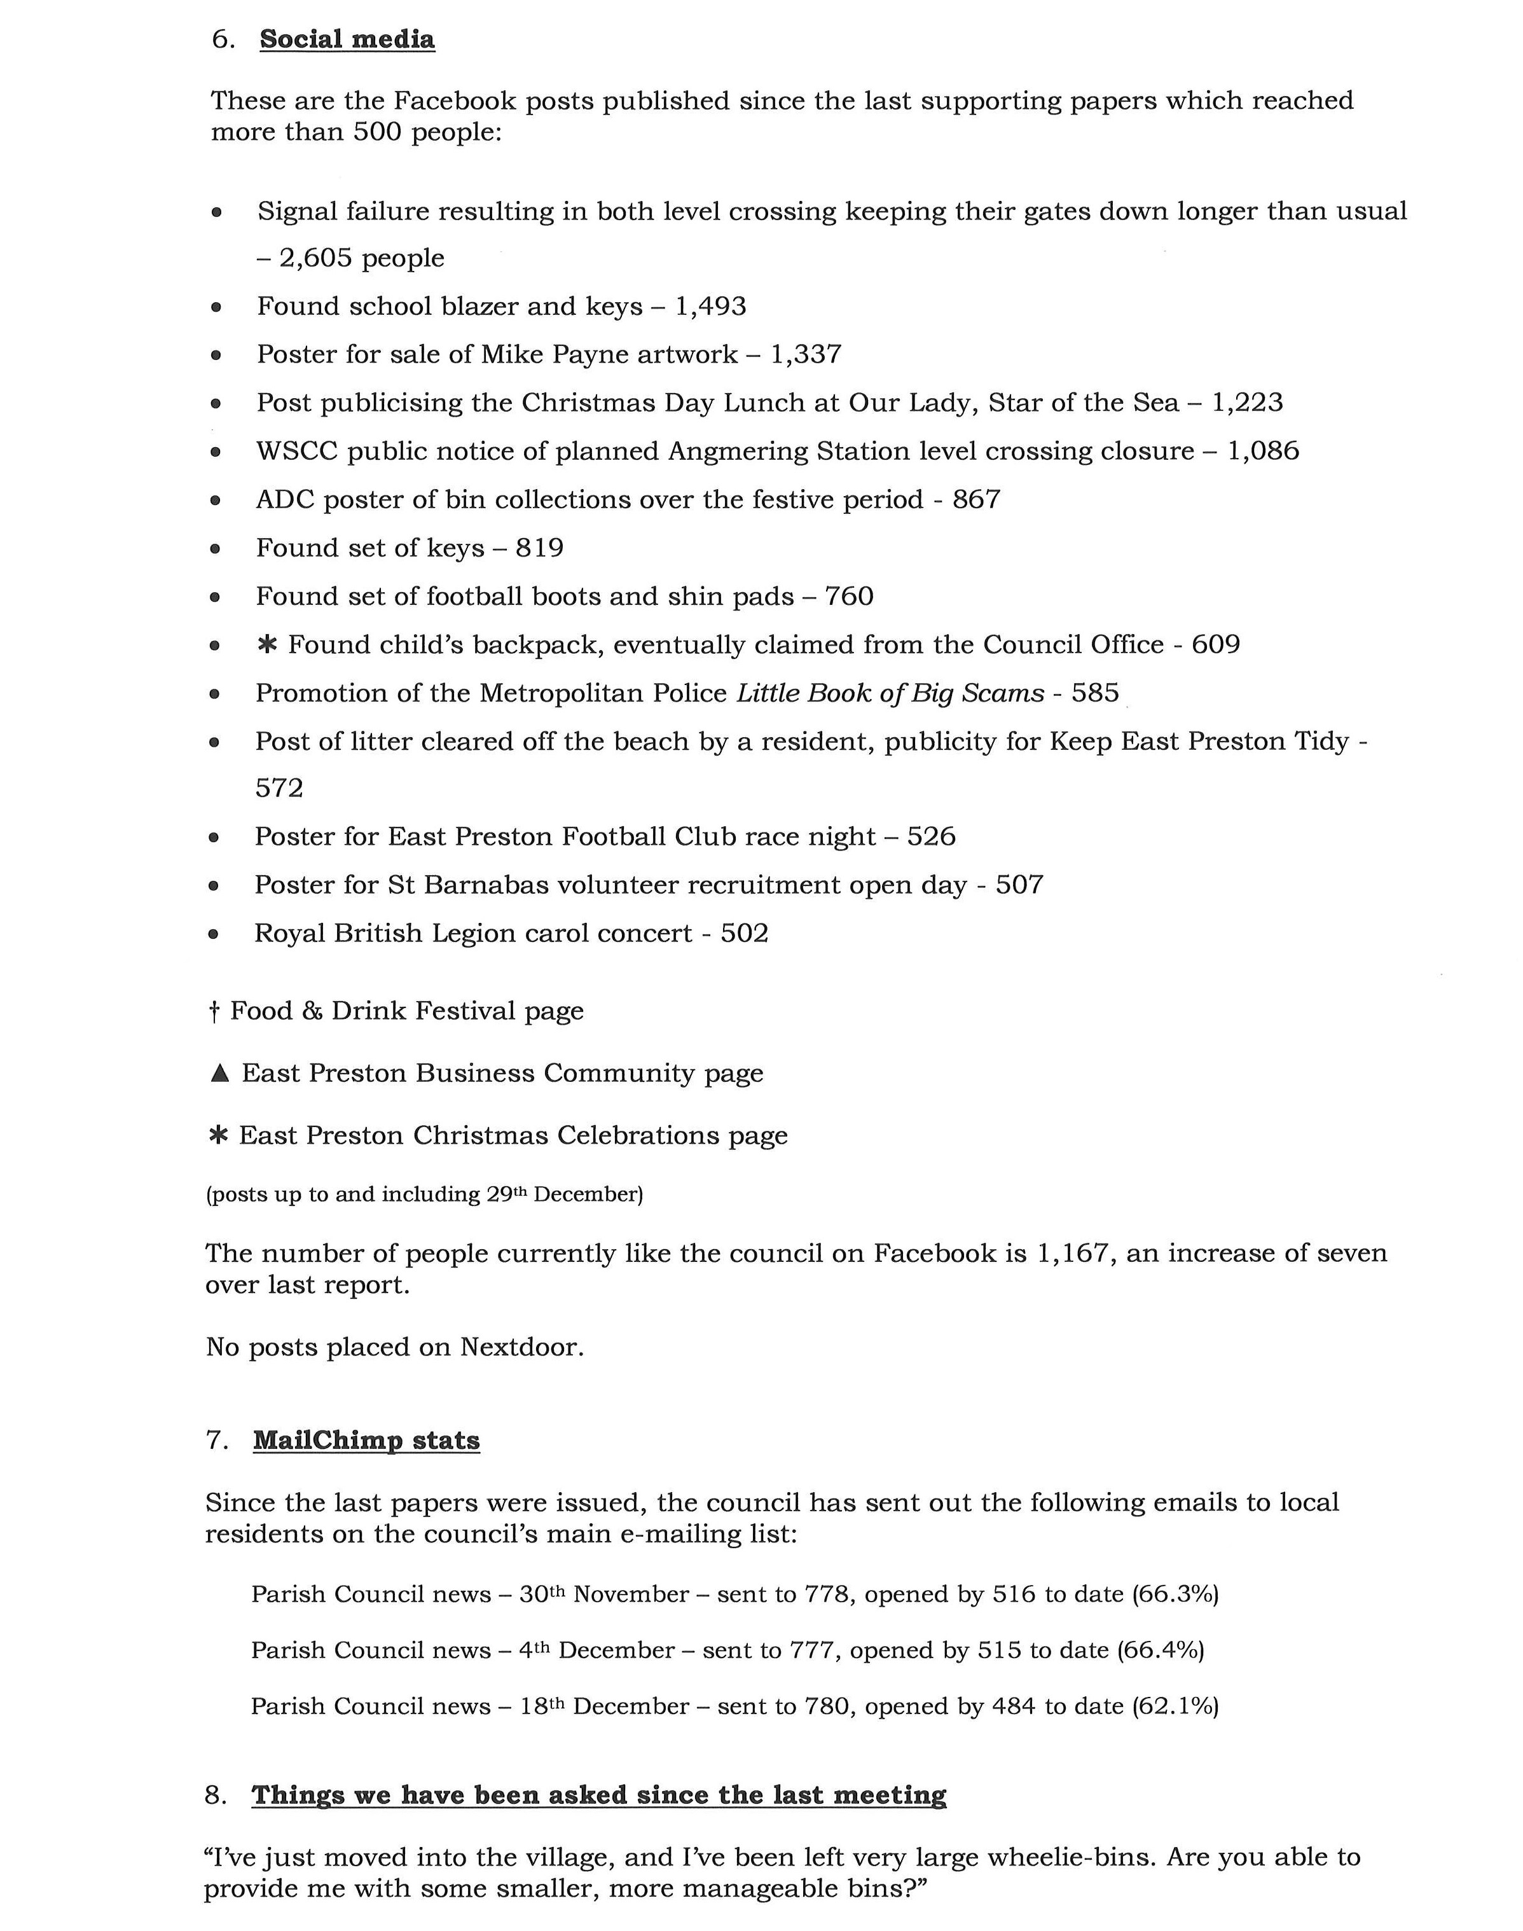

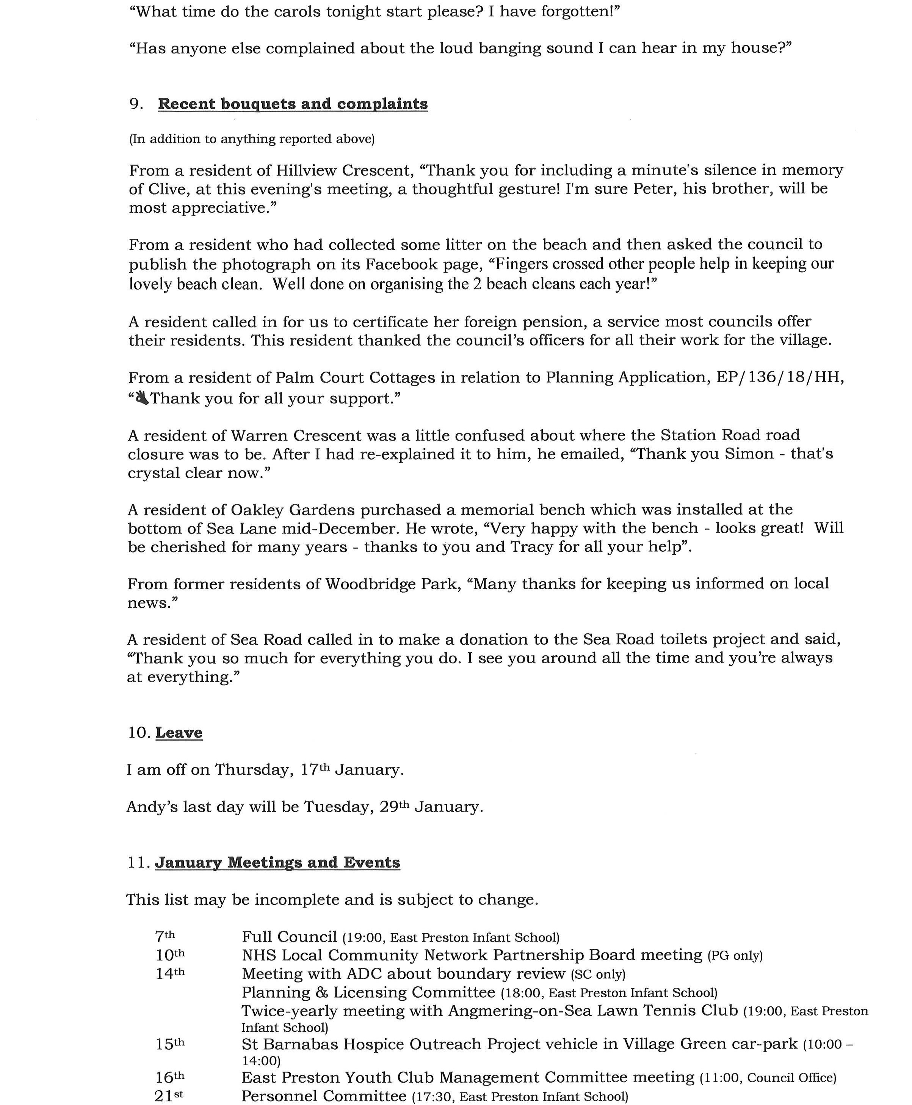

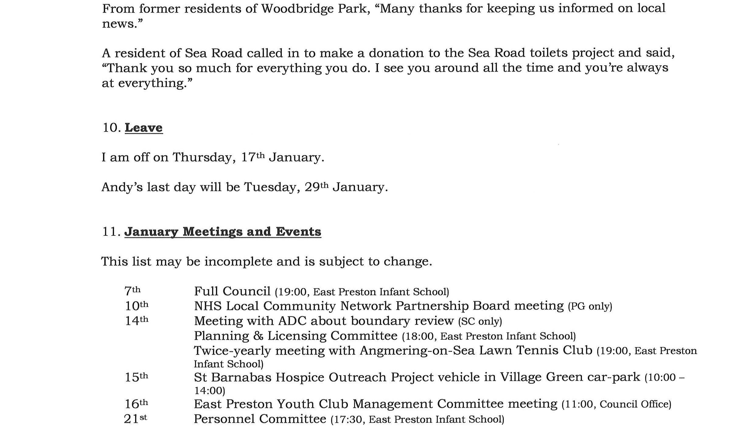
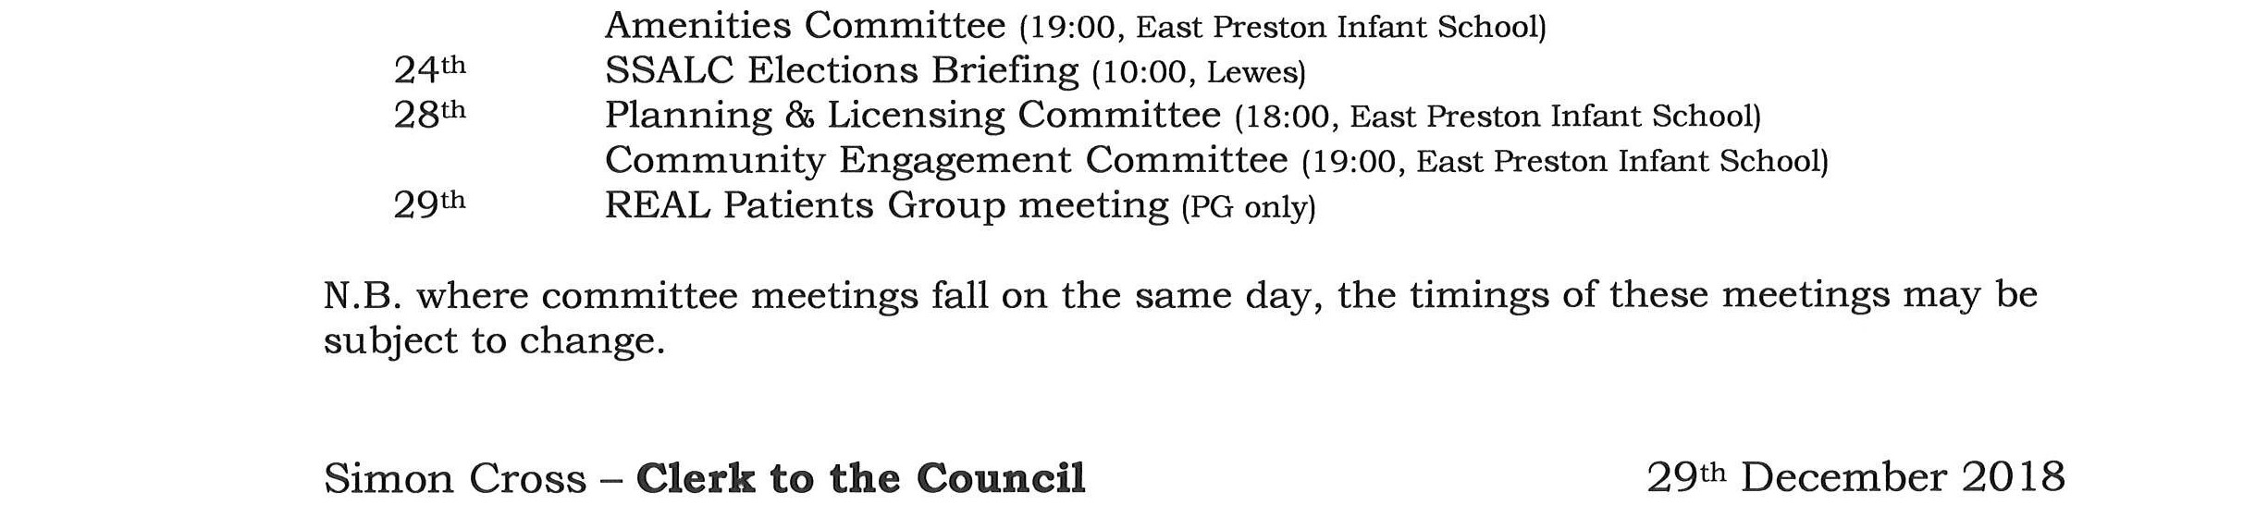

The Chairman thanked the Clerk for his report.

023/19 EXTERNAL MEETINGS AND EVENTS

The council NOTED the following reports which had been circulated in advance of the meeting:

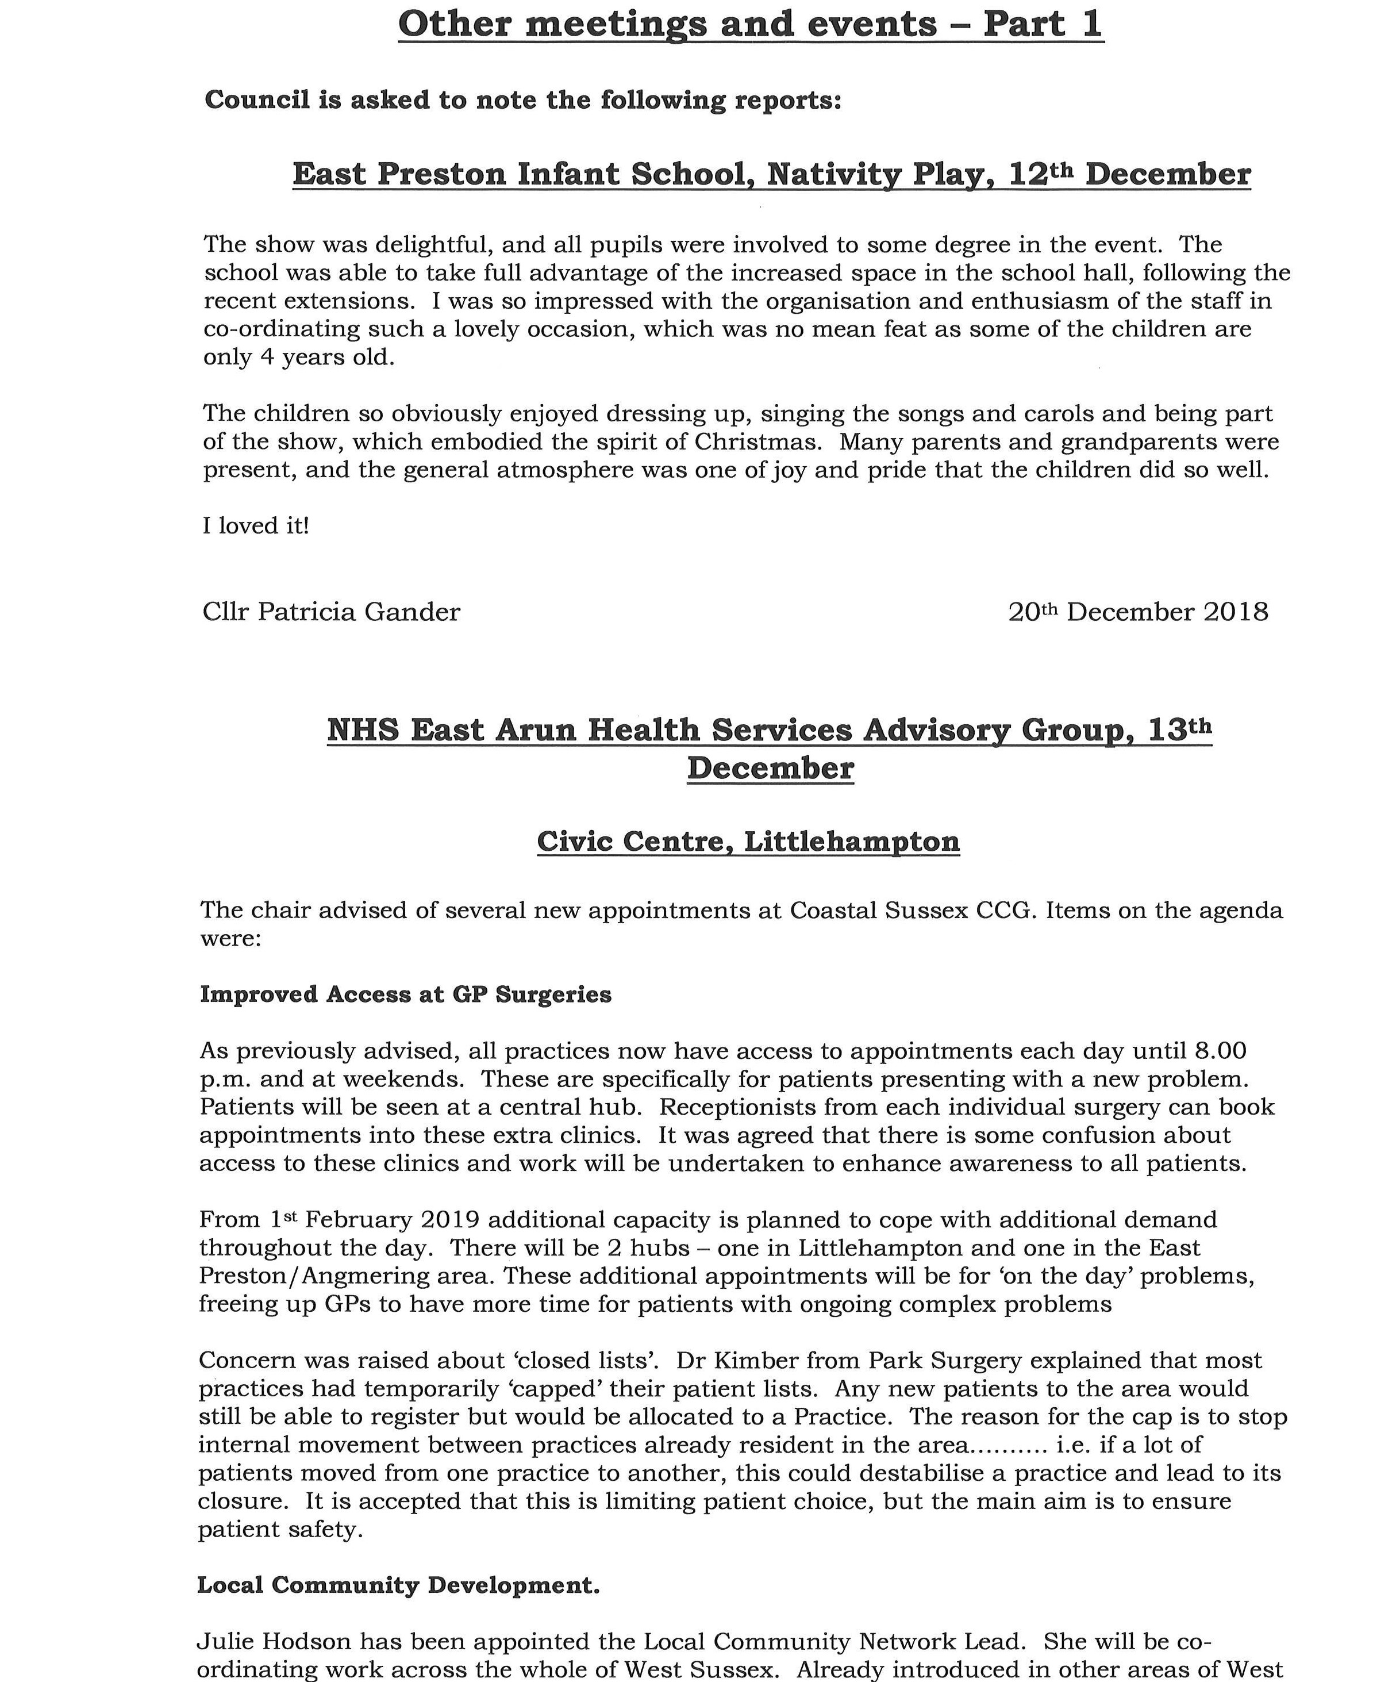
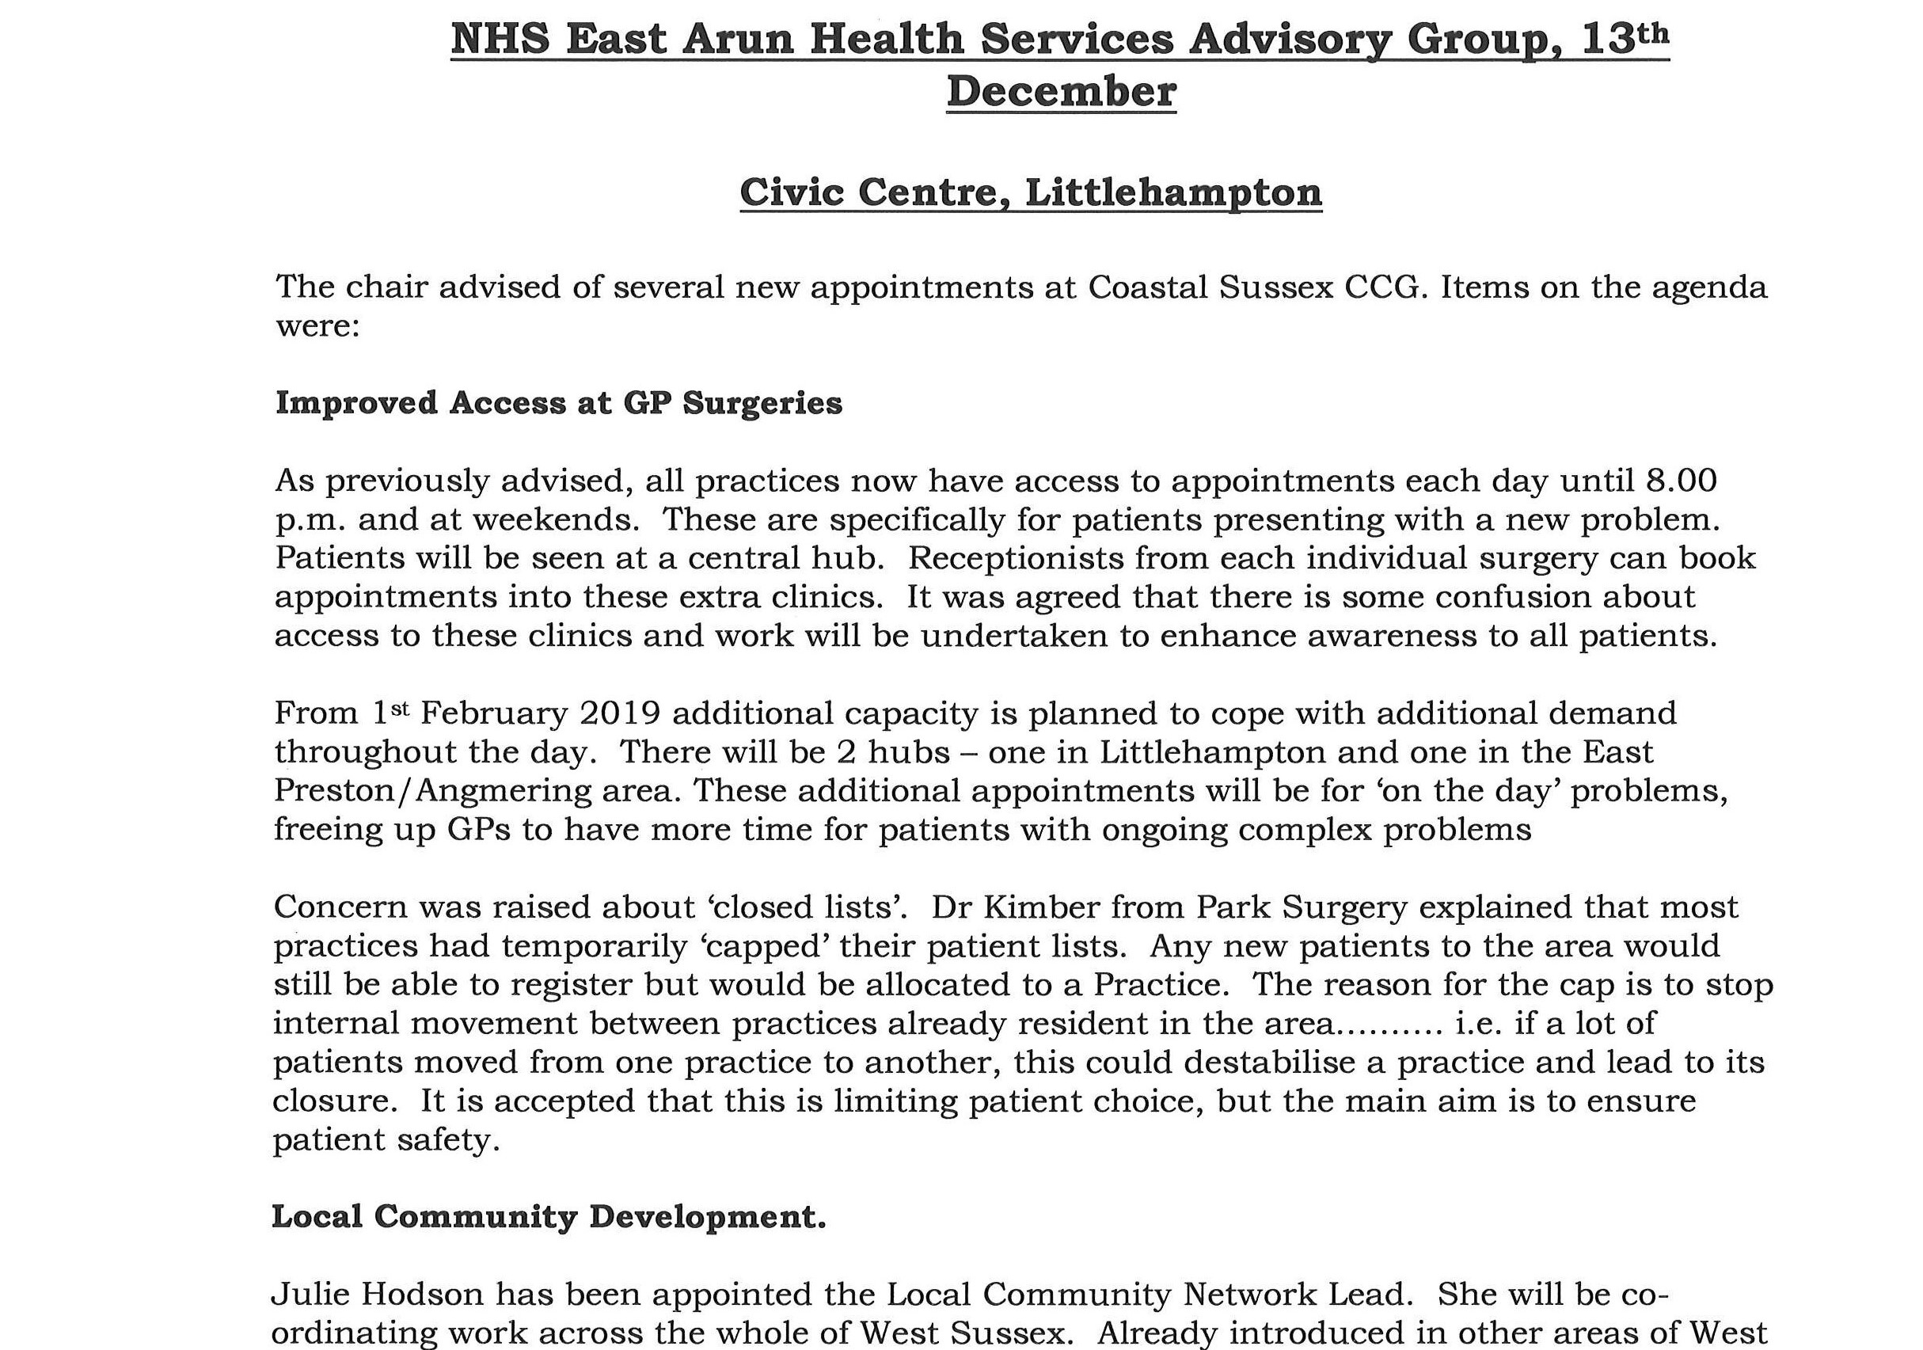
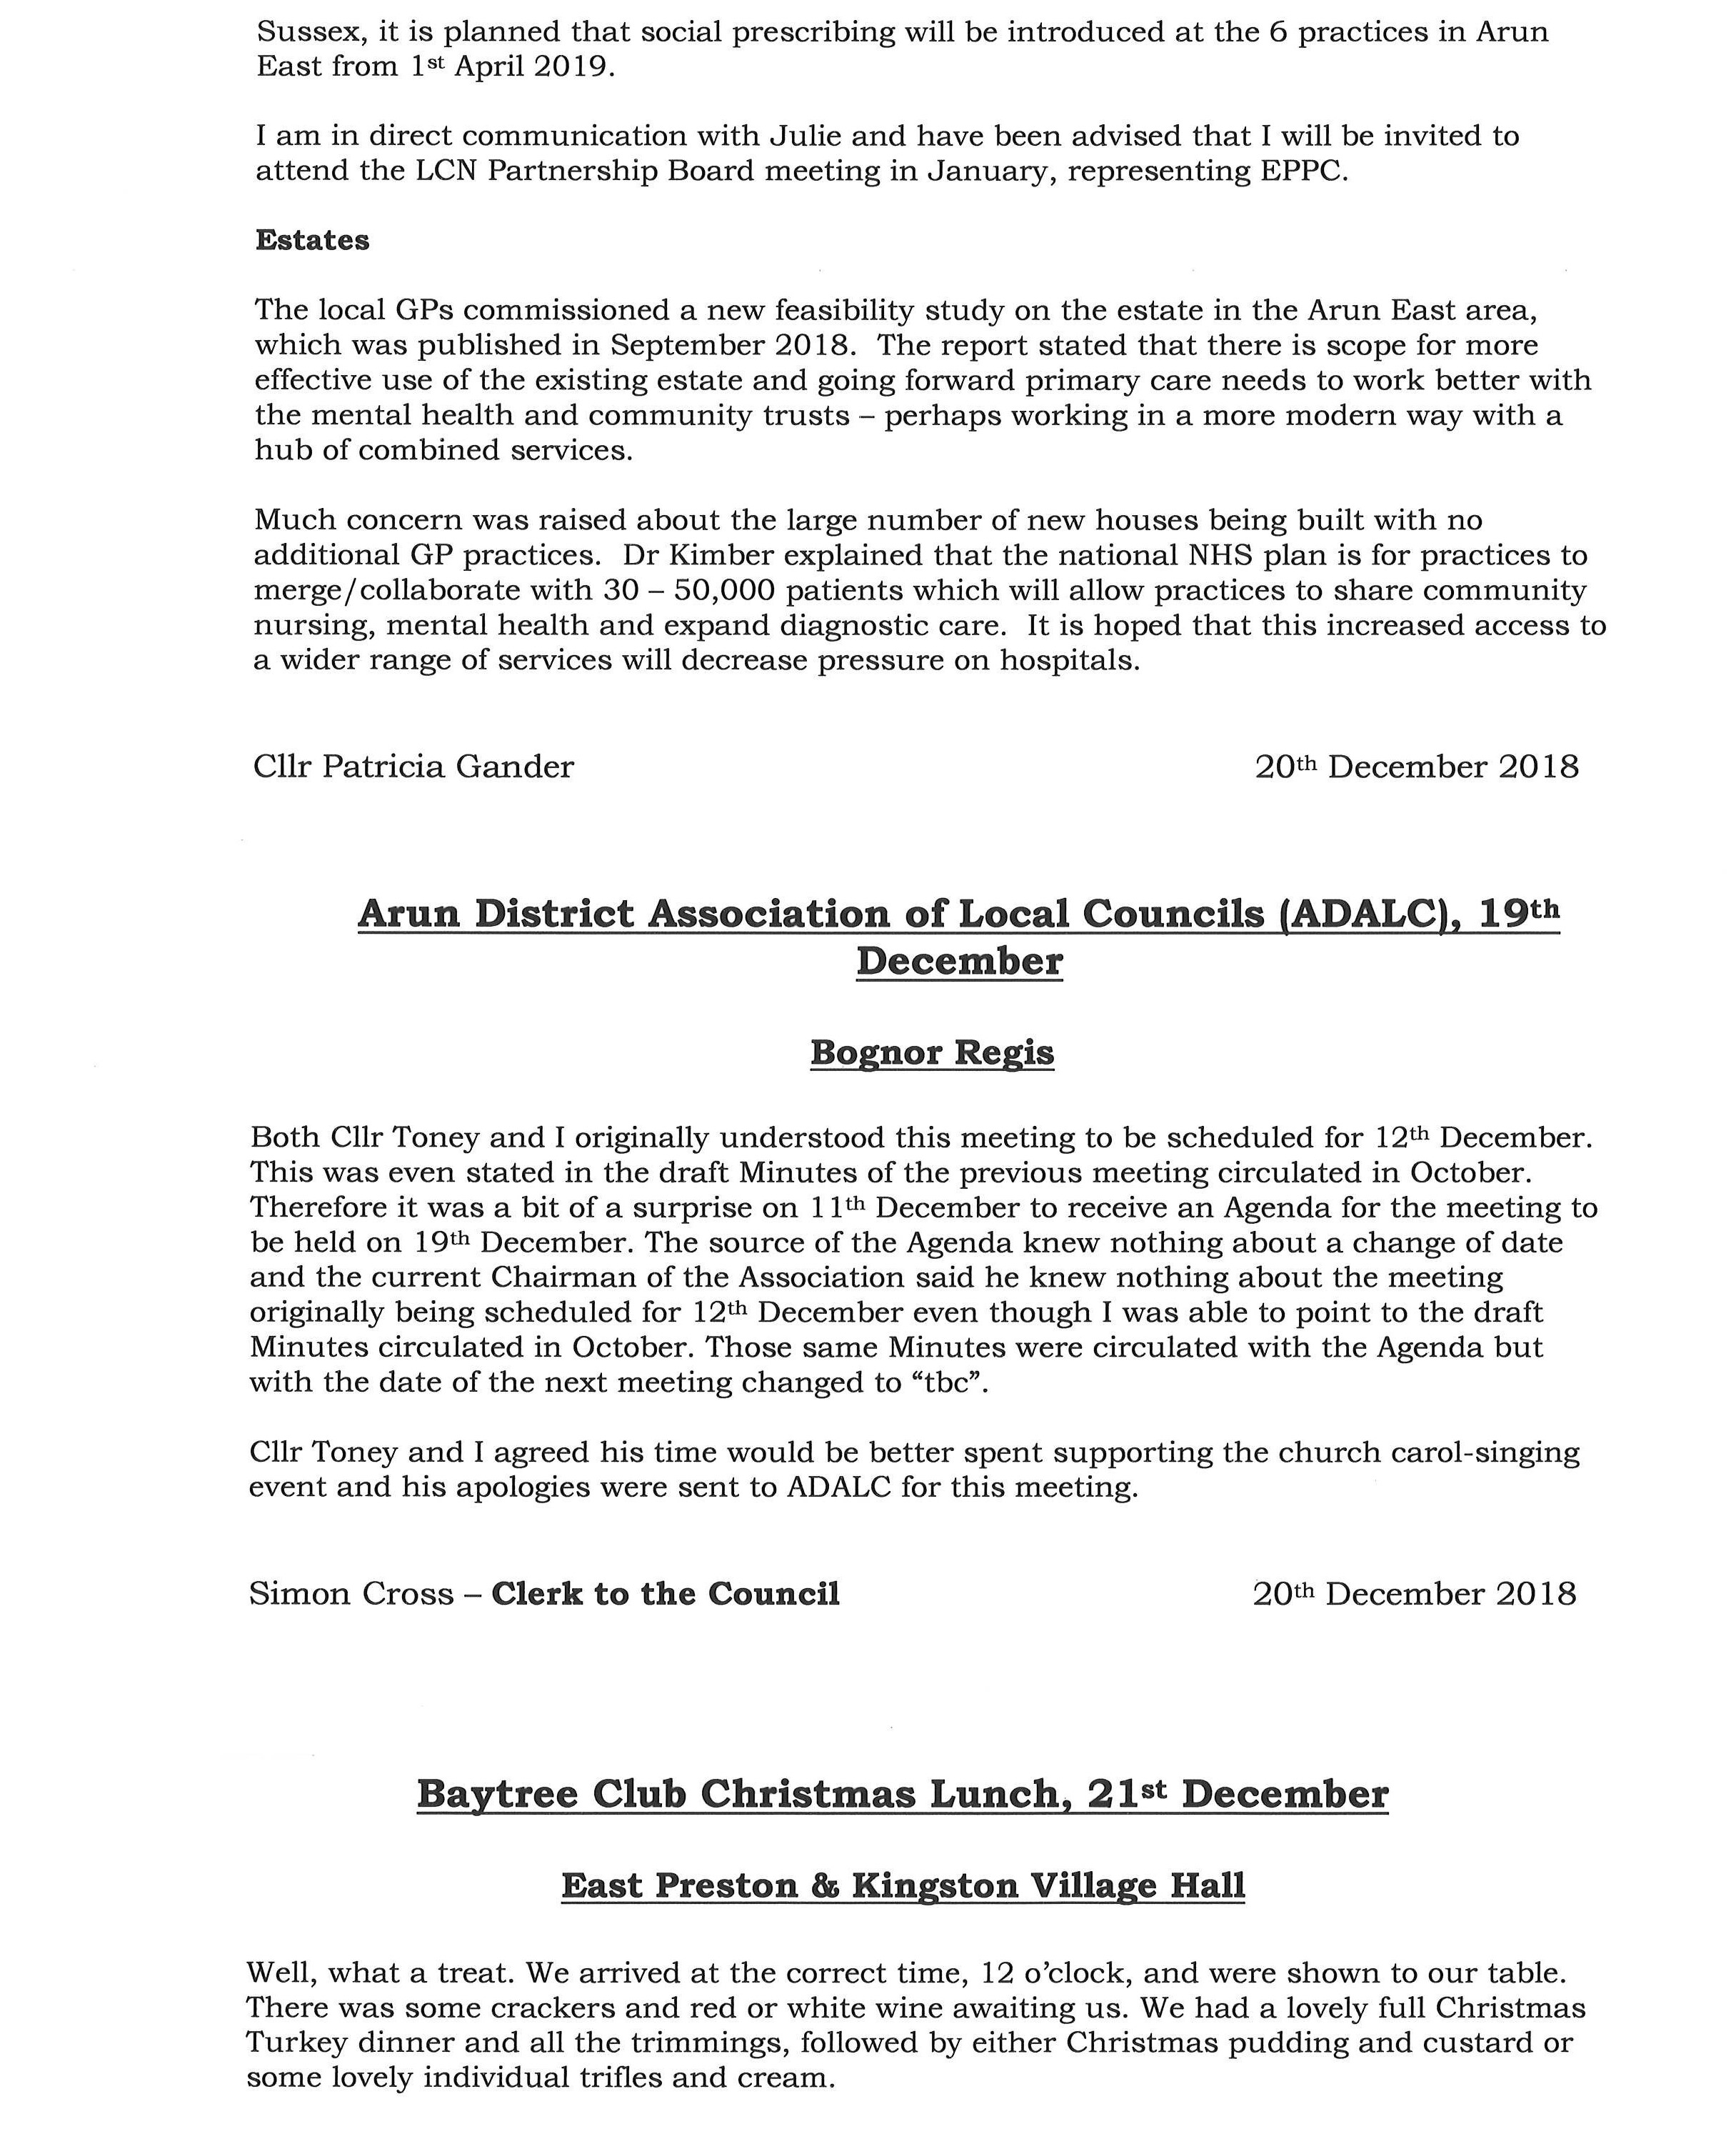

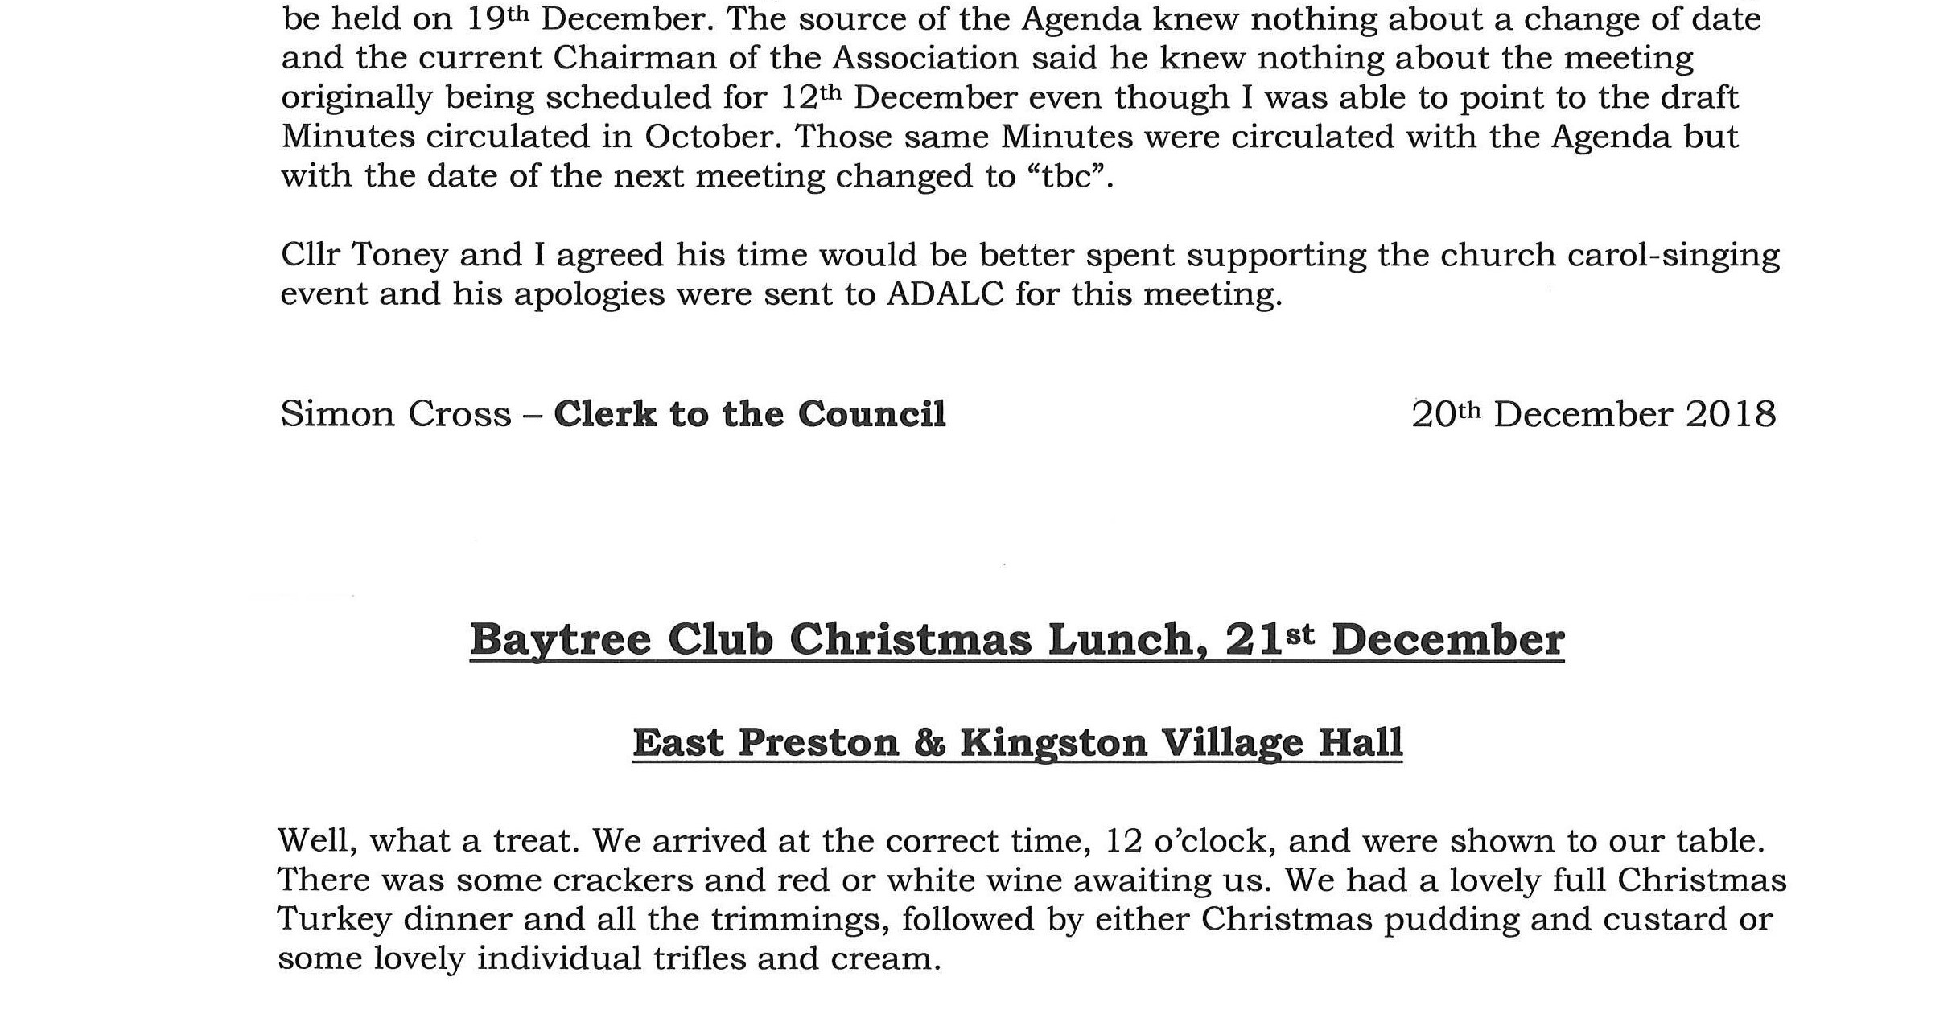
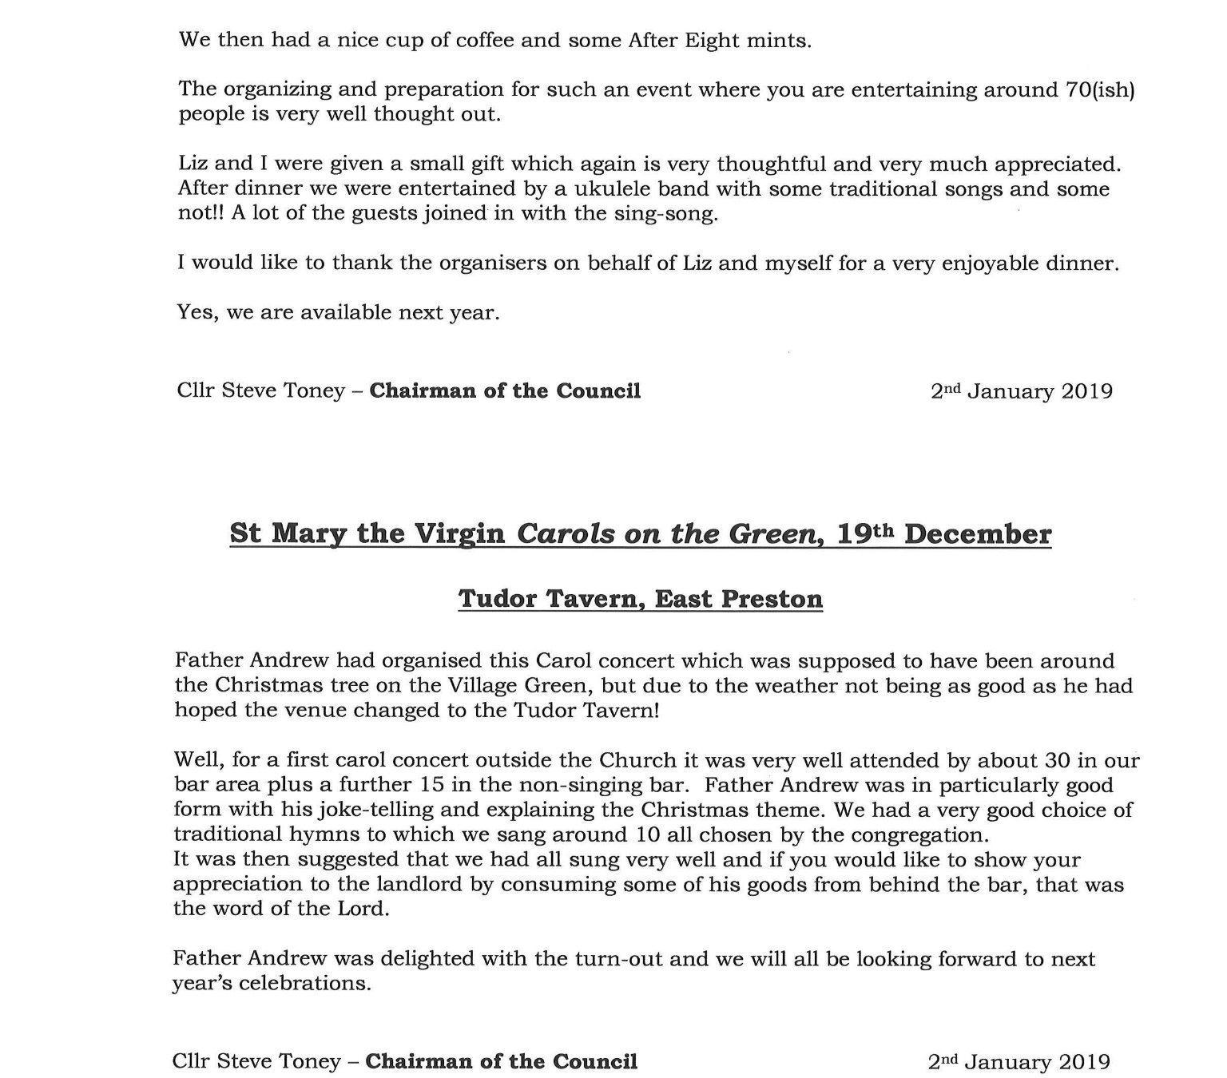

024/19 RESPONSE TO EXTERNAL MEETINGS AND EVENTS

Nothing was added.

025/19 NEW ITEMS FOR THE NEXT MEETING (4TH FEBRUARY 2019)

Cllr Chapman asked whether anyone had any news on whether or not the new school for Angmering, mentioned by District Cllr Bower at the last meeting, was still going ahead. It was agreed it would be best to ask District Cllr Bower this directly at the next meeting.

The meeting concluded at 20:30

Chairman: ……………………………………………….. Date: 4th February 2019
Councillor Steve Toney

END

